Информация о реализации программы « Біртұтас тәрбие»
за первое полугодие 2024-2025 учебного года
в средней школе №16 им. Т.Айбергенова

№ | Название мероприятия | Дата проведения | охват | фото | ссылка
1. | «Менің Отаным - Қазақстан» тәрбие сағаты | 02.09.24 | 2845 | 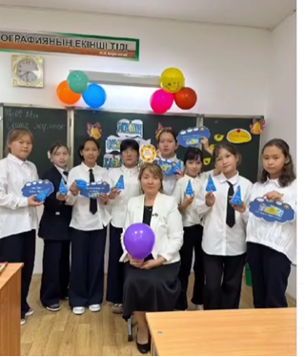 | https://www.instagram.com/reel/C_Z_rc7NuaS/?igsh=emN3ejJwOHk0Z3F0  https://www.instagram.com/reel/C_ay2KjNhGG/?igsh=MXZ3Z3gzbmg1bTJobg==  https://www.instagram.com/reel/C_a7lWxNkuh/?igsh=MWp3bXBpaDhqcmhydw==  https://www.instagram.com/reel/C_a8F7tNEDt/?igsh=MXFjdWpiOXE2Mml4bA==  https://www.instagram.com/reel/C_a8mxANm-t/?igsh=d3YwdXZ0Nml1empp  https://www.instagram.com/reel/C_a-taFNW8a/?igsh=MW44MHUza3gycDBhMQ==  https://www.instagram.com/reel/C_a_Hgit73o/?igsh=ampmcHRtZzBnNmhq  https://www.instagram.com/reel/C_bBIhgtbqB/?igsh=cGJqZGxlZ2sxdmN1  https://www.instagram.com/reel/C_bEHGsNzQ9/?igsh=MWN1M2l6ZmdmeWdjZA==  https://www.instagram.com/reel/C_bSJ2HN3hr/?igsh=ejBybzQwOXFmM2xt  https://www.instagram.com/reel/C_cfo6PNv8L/?igsh=YWZtY2JpNjJmZXdj
2. | Республиканская акция «Внимание - дети!» | 1-6.09.24 | 1300 | 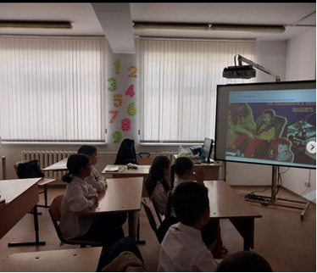 | https://www.instagram.com/p/C_c0pLdtm2Z/?igsh=dmI3OHk0YnhiOGhw
3. | Флешмоб, посвященный Дню семьи под названием “Дені сау ұрпақ”. | 05.09.24 | 300 | 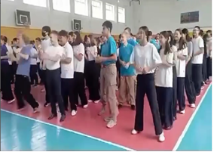 | https://www.instagram.com/reel/C_iBUNBNJMP/?igsh=NWpyNWs0NGdrNDJi  https://www.instagram.com/reel/C_iCFaltcCC/?igsh=MXduNDh2cjhvaHNxZw==  https://www.instagram.com/reel/C_iKs0kt4nH/?igsh=Z3p3cTFjdmlka24=
4. | Классный час «Жанұям– қорғаным, ата-анам – тірегім!» | 09.09.24 | 2845 | 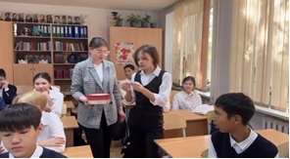 | https://www.instagram.com/p/C_lDKY4NbGP/?igsh=MTVxZTJ2MWN4c3VxcQ==  https://www.instagram.com/reel/C_srLsUt-IR/?igsh=cHo2a29qeGY2OTZu  https://www.instagram.com/reel/C_ssEqpNs1T/?igsh=dm1raGR3emEzZ3M3  https://www.instagram.com/reel/C_tQMzONrO2/?igsh=MWdpMmpjNDhxeDJzNg==  https://www.instagram.com/reel/C_v2bjiNuj6/?igsh=OXdvamVlMXMwc2pn
5. | Мероприятия «Қазақстан халқының тілдер күні» | 05.09.24 | 800 | 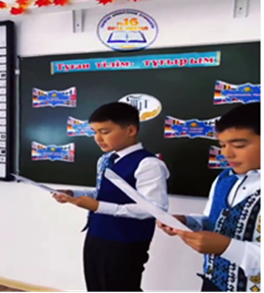 | https://www.instagram.com/reel/C_kv458N5as/?igsh=MXNwbGhuazVteGVqeQ==  https://www.instagram.com/reel/C_nHLYDtFvR/?igsh=ZDkwYXBrY2Niajl6  https://www.instagram.com/reel/C_lX6A5tPUI/?igsh=MTI4dm1xOTR5dW1lcw==  https://www.instagram.com/reel/C_lViXCtBHD/?igsh=aGc1ZXk0aHhhNnFk https://www.instagram.com/reel/C_iPF85NHCn/?igsh=ZGdra2FxZHdodmZ1  https://www.instagram.com/reel/C_t_f05iI1K/?igsh=aGxkdDZ0aWc3NG40  https://www.instagram.com/reel/C_x6NDaNJE7/?igsh=Z2FieHBzZnVzdGFh  https://www.instagram.com/reel/C_x62-jNJkE/?igsh=MmNjYW8zbXg1c2hm
6. | «Ұлттық ойындар - бабадан қалған асыл қазына» атты отбасылық ойын жарысы | 13.09.24 | 30 | 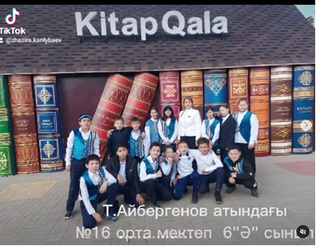 | https://www.instagram.com/p/C_4qbiHNl4s/?igsh=MTIyNmxzOWhlaWxwMQ==
7. | Қауіпсіздік техникасы және өзін-өзі ұстау ережелері бойынша кездесу | 16.09.24 | 150 | 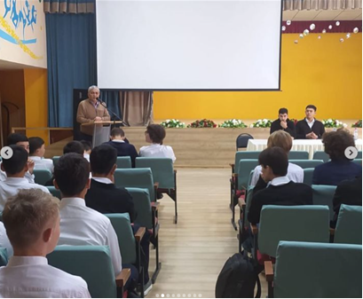 | https://www.instagram.com/p/C_9z2uRIYmN/?igsh=eW11bnFhZnh2b3Zn
8. | Классные часы по антибуллинговой программе программе «KiVa» | Каждый понедельник | 825 | 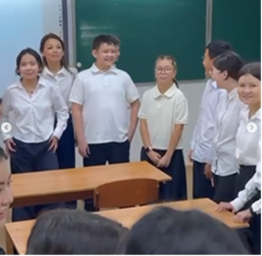 | https://www.instagram.com/p/C_-I0kIo8QI/?igsh=MWZvZTlsMDN1bWIwdg==  https://www.instagram.com/reel/C__Jj1gNGtP/?igsh=cTZ4d2Z0MjFjaDhw  https://www.instagram.com/reel/DAQrb93tbws/?igsh=Zjl0MzByZjN5YXp3  https://www.instagram.com/reel/DAQskFgtLkJ/?igsh=MXNicGU2eHF2eGJncg==  https://www.instagram.com/reel/DAQr_IKt9zM/?igsh=MWMzbXF4bXpscnV0bw==  https://www.instagram.com/reel/DAQuOP3Nqsk/?igsh=MnZoMng0ZnRzdmtq  https://www.instagram.com/reel/DAQugEpts1D/?igsh=amg1a2kxeGpsMGJ2  https://www.instagram.com/reel/DASyZFxNHl6/?igsh=bXh1bmxqYjZmMmNv  https://www.instagram.com/reel/DASy4xbtCpY/?igsh=MTA1N2NoemZhdXE5cw==  https://www.instagram.com/reel/DAS0BaKtaxc/?igsh=cHdzZDNpZjlnd2lu  https://www.instagram.com/reel/DAS0LbHtwlZ/?igsh=MWgxc2JkZXVidzJleA==  https://www.instagram.com/p/DAS1sZptmuZ/?igsh=MTE2cW83b2x5dmc4dw==  https://www.instagram.com/reel/DAS12abt4T2/?igsh=bGI4eWJxazl3Y3Jj  https://www.instagram.com/reel/DATTekQt8jg/?igsh=MXRvdGlleHBrMHVpNw==  https://www.instagram.com/reel/DATTwLGtjoz/?igsh=d2kydDFma2V6ams5  https://www.instagram.com/reel/DATT8S1NPYs/?igsh=cXo1amwxcjI0eWV0  https://www.instagram.com/reel/DATURY-Ng-x/?igsh=MWFzbmFrbzE5NHhjdQ==  https://www.instagram.com/reel/DATU1c6tu3I/?igsh=MXZkeWkyMjM4cW5rMQ==  https://www.instagram.com/reel/DATV5qeNYsn/?igsh=MWt5dDU5MThxczU2ZQ==  https://www.instagram.com/reel/DAT2gu4NS2Q/?igsh=bDE5ZW9nZWNmazRl  https://www.instagram.com/reel/DAT27rRNgaL/?igsh=MTFyMmM4dWNpcGkwMA==  https://www.instagram.com/reel/DAVgp1FN7YD/?igsh=Y3o3OWdtcW9mNXp4  https://www.instagram.com/reel/DAVhRWaNtyP/?igsh=dWl1d3l4enJ2ODVq  https://www.instagram.com/reel/DAiAijztPJ1/?igsh=eGVvMmZibnpwZWVz  https://www.instagram.com/reel/DAiyUyotALa/?igsh=MTl3cmVzbHIxYzdyZw==  https://www.instagram.com/reel/DAirWoFtFSH/?igsh=MWlpd2Q5cXNzbnJreQ==  https://www.instagram.com/p/DAi128Ott6z/?igsh=MTh1cGZ0bDl1djcyZQ==  https://www.instagram.com/reel/DAi2JmSNZzo/?igsh=MXc3ejNha210YjF0Yw==  https://www.instagram.com/reel/DAjLpUWNrAl/?igsh=MWx5eTVnZW5zcTNnYg==  https://www.instagram.com/reel/DAkhuF3NkHQ/?igsh=MXY4YXljeWEzdHJwcQ==  https://www.instagram.com/reel/DAlCFQdtoZx/?igsh=MXJwamNjOWRrNTdqNw==  https://www.instagram.com/p/C__bxcBtIF2/?igsh=MTdpNmZsbWl3Y2p0Zg==
9. | Общешкольное родительское собрание «Разъяснение по внедрению антибуллинговой программы KiVa» | 12.09.24 | 150 | 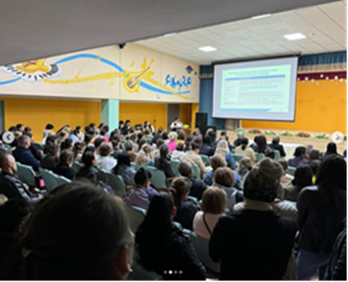 | https://www.instagram.com/p/C__cHs9Nxzs/?igsh=a3d2dGxsNXNwY21z
10. | «Тазалық- денсаулық кепілі!»-субботник | 21.09.24 | 300 | 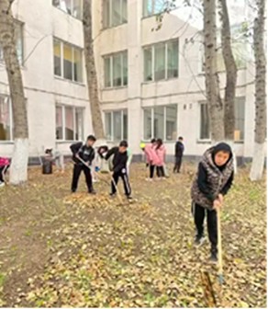 | https://www.instagram.com/reel/DALHffstXJn/?igsh=NTI3d3RmbTY3OTht  https://www.instagram.com/p/DALSqfPNh3a/?igsh=b2tlcTRxOTR0NG5w  https://www.instagram.com/reel/DAYCiT8Nde1/?igsh=OHFpYTllbWlsODJv  https://www.instagram.com/p/DAZmKRbist5/?igsh=NXpsajJxb3FqYTFr  https://www.instagram.com/p/DAcxhBvt8Zd/?igsh=cWZoZzEwY2R6dzgw  https://www.instagram.com/reel/DAdRCU3teAv/?igsh=azF2aWYycnNibHRw  https://www.instagram.com/p/DAgkSoBN_oH/?igsh=MWoyODk0cXRqcXZoNw==
11. | «Астана - тазалық пен тәртіптің үлгісі»-субботник | 28.09.24 | 200 | 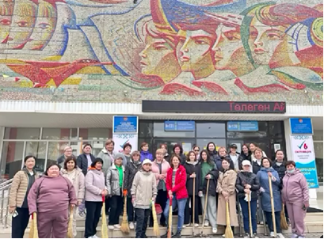 | https://www.instagram.com/reel/DALHffstXJn/?igsh=NTI3d3RmbTY3OTht  https://www.instagram.com/p/DALSqfPNh3a/?igsh=b2tlcTRxOTR0NG5w  https://www.instagram.com/reel/DAYCiT8Nde1/?igsh=OHFpYTllbWlsODJv  https://www.instagram.com/p/DAZmKRbist5/?igsh=NXpsajJxb3FqYTFr  https://www.instagram.com/p/DAcxhBvt8Zd/?igsh=cWZoZzEwY2R6dzgw  https://www.instagram.com/reel/DAdRCU3teAv/?igsh=azF2aWYycnNibHRw  https://www.instagram.com/p/DAgkSoBN_oH/?igsh=MWoyODk0cXRqcXZoNw==
12. | Ұлттық музейде «Алтын адам археологиялық олжасы» тақырыбында ашық сабақ өтті. | 19.09.24 | 25 | 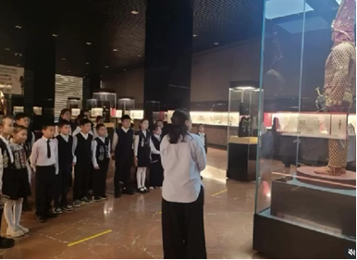 | https://www.instagram.com/reel/DAKZw7BiXNX/?igsh=MXV3ajZyN2tjdTFnMg==
13. | «Прокурор сағаты – есірткі және жасөспірімдер» тақырыбында кездесу | 21.09.24 | 150 | 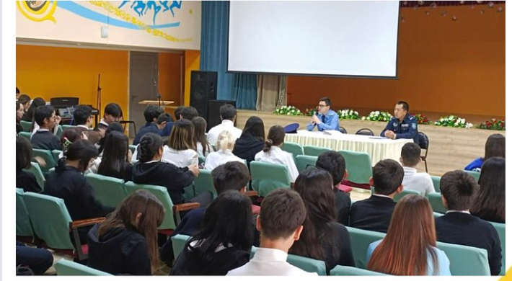 | https://www.instagram.com/p/DALUpyAtRzx/?igsh=NGpqYmZ3OW82dW04
14. | Классный час «Еңбек - түбі береке». | 21.09.24 | 2800 | 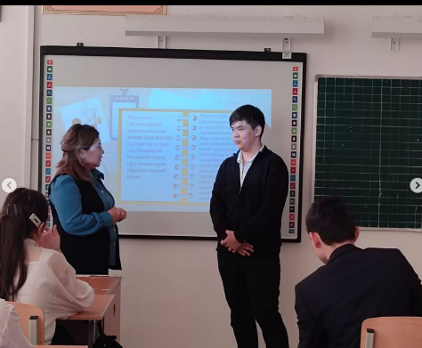 | https://www.instagram.com/p/C__dMnBNJTY/?igsh=MXNobXUwNDZkeHo5OQ==  https://www.instagram.com/reel/DAGMigwIJ7f/?igsh=MTZyMHE5eWYwMjVmcw==  https://www.instagram.com/p/DAGflsltzBO/?igsh=aDVqd2c2aWlmenpq  https://www.instagram.com/reel/DAHFNpsN96d/?igsh=MTNnd3l4ZHdlM2Rwbg==  https://www.instagram.com/reel/DAQs88QN68d/?igsh=MXNtYjZ0NWthZnhoOQ==
15. | «Бұрымды қыз» челленджі | 24.09.24 | 40 | 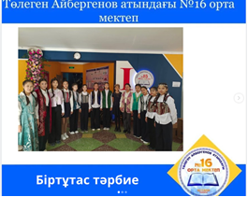 | https://www.instagram.com/p/DAS-3CwtXj6/?igsh=NTVxY25ydWFoMDl2  https://www.instagram.com/reel/DAS-7TZtPFx/?igsh=MWliYThhZ255dXliZg==
16. | Лекция с капитаном полиции Оразгалиевым А.М. на тему: Правила дорожного движения | 25.09.24 | 475 | 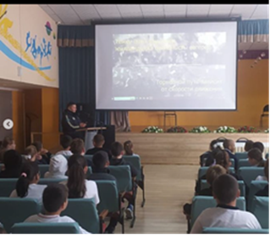 | https://www.instagram.com/p/DAVhEGmtve3/?igsh=MWN1cDBoeXoxc2owcA==
17. | “Көңілді старт” эстафетасы | 25.09-03.10 | 600 | 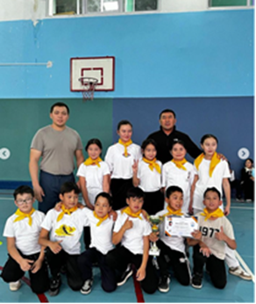 | https://www.instagram.com/p/DAVgU81tFko/?igsh=MTFlemd3a2MzZ2Jlcw==  https://www.instagram.com/p/DAWSw5xtYNO/?igsh=YzF5MXIxdDEyaWZo  https://www.instagram.com/reel/DAWS5sSND-2/?igsh=MmM4enpqb29nczM5  https://www.instagram.com/reel/DAWS7HFtxNx/?igsh=MTllOG81ZmxtZ2g4NQ==  https://www.instagram.com/p/DAWTHywNMsy/?igsh=b29jaW9scXAzZXdh  https://www.instagram.com/reel/DAZnUuBCAYm/?igsh=MWxsOXUyM3JjNGFzcg==  https://www.instagram.com/p/DAboM_PNa2m/?igsh=MXp3bWdnemhsemx1  https://www.instagram.com/p/DAcxB4HteBR/?igsh=aHQza2NwZzcwbjA1  https://www.instagram.com/p/DAn975Zo5PW/?igsh=dnk2NHc0dDAwN2dh  https://www.instagram.com/reel/DAoZ4BBtfGR/?igsh=MWxzZDRkczJnbmlydg==  https://www.instagram.com/reel/DAoabkUtjem/?igsh=Ym5qOWZndjZ0a21h https://www.instagram.com/p/DApBrSliL8q/?igsh=MXV1OHlvajlpcThzZA== https://www.instagram.com/reel/DAqNgonN23B/?igsh=cnBldGc1eWdvbWJu  https://www.instagram.com/reel/DAxrLG1NkOe/?igsh=aDY0MWticW01eWZw  https://www.instagram.com/p/DA-_hLJNMEJ/?igsh=OTZpNmVwcjBiemg3  https://www.instagram.com/reel/DA_kQMQtcBM/?igsh=MWg5bnY2ZTF6aWNhdQ==  https://www.instagram.com/reel/DBHGfDSNnfE/?igsh=bmx1d3NwMXk1ZDl0  https://www.instagram.com/reel/DBHTXUltVQY/?igsh=MTQxZXc2YmRnbG1xdA==
18. | «Бала қауіпсіздігі – қоғамның басым бағыты»-общешкольное родительское собрание | 26-27.09.24 | 300 | 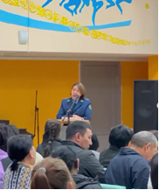 | https://www.instagram.com/p/DAa31HcNMkV/?igsh=MTNrN3Y2aXk2ZGFuZQ==
19. | Экскурсия в «Национальный музей Республики Казахстан» | 27.09.24 | 30 | 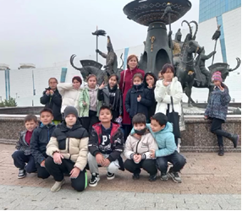 | https://www.instagram.com/reel/DAbZQyINJzE/?igsh=b243bjdseGVqcnQ=
20 | классные часы на тему «День пожилых» | 30.09.24 | 2770 | 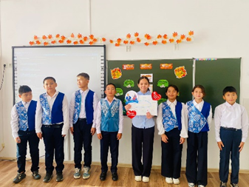 | https://www.instagram.com/reel/DAi06_ENkDm/?igsh=eTlkN2IwcXo1eGg0  https://www.instagram.com/p/DAi1Zt0tUMQ/?igsh=aWI5ZGdlcWRxNTVy  https://www.instagram.com/reel/DAi1iipN5A0/?igsh=aHE2ZTBtemNlajU4  https://www.instagram.com/reel/DAjKgrvNGho/?igsh=MzA1a2l3cGZ5MXN2  https://www.instagram.com/reel/DAjK7c4NN-w/?igsh=MW03dTBqb2d1cmYyaA==  https://www.instagram.com/reel/DAjK2mct-wt/?igsh=Zzlhb2FlMzBoNXFs  https://www.instagram.com/reel/DAjLWhctWhl/?igsh=MW5objZjeWkzNXhxdQ==  https://www.instagram.com/reel/DAm4A2JtxcO/?igsh=NmF4bWlsaHFyZmdv  https://www.instagram.com/reel/DApA6CLtGRe/?igsh=MW1tODRoOWczcmJoYw==
21 | Челендж «Даналық ұстаздан»! | 03.10.24 | 510 | 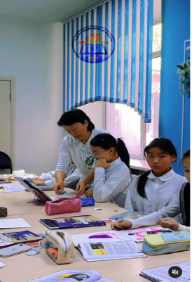 | https://www.instagram.com/reel/DApzU3KNTCn/?igsh=NnA5cHBxNmk3cm9j
22 | классный час, посвящённый Дню учителя | 03.10.24 | 2770 | 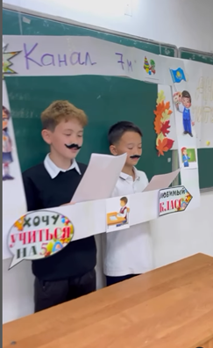 | https://www.instagram.com/reel/DAqMYKVtSkI/?igsh=Z3ZnZDR5cnEwaHpx  https://www.instagram.com/reel/DAqNOwFtJQ-/?igsh=MW94b252cXlmNTNrZQ==  https://www.instagram.com/reel/DArA0HyNzML/?igsh=cTRkcGxzNWI0Y2g0  https://www.instagram.com/reel/DArHwDPNXZZ/?igsh=MTA1NmJrd2Iwd3JheQ==  https://www.instagram.com/reel/DAsR1FJN8Ok/?igsh=MWF0ajNjdGQ2OWpy  https://www.instagram.com/reel/DAsSAd5Na1d/?igsh=aGNvZzg2MXlmZzA=  https://www.instagram.com/reel/DAsS7UotVX3/?igsh=MTN2d3J6NDhta2c0Nw==  https://www.instagram.com/reel/DAsXLqiNh2K/?igsh=MTJ5aG9wa3FzdXZrOQ==  https://www.instagram.com/reel/DAsYXiyNF6x/?igsh=MW04bmliM21sMHVvZQ==  https://www.instagram.com/reel/DAsgrnIt4GY/?igsh=MWQ3ZXJsanVqajlqag==  https://www.instagram.com/reel/DAshdRgtTFe/?igsh=eW5sdm11bTU2bHQ5  https://www.instagram.com/reel/DAshoietZo5/?igsh=MXJwdzUzdmNtbnJnYw==  https://www.instagram.com/reel/DAskah_tZ5_/?igsh=MXRua2xiaWxpaHY1OA==  https://www.instagram.com/reel/DAskzQgNgSA/?igsh=MXExaWxzZjRwZzc3bw==  https://www.instagram.com/reel/DAslvjTtRi5/?igsh=MTh5NHN4MjRwaXJp  https://www.instagram.com/reel/DAstZw4Nd9h/?igsh=MWwzbndmeGFieGJ4Zw==
23 | День дублера | 04.10.24 | 350 | 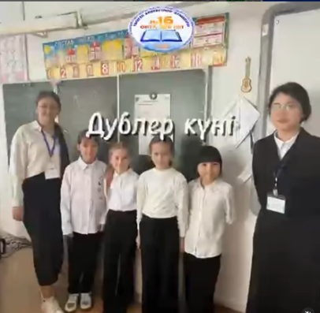 | https://www.instagram.com/reel/DAsbszHtNjL/?igsh=MXM2eTJqdDdjZ21ocg==
24 | классные часы по антибуллинговой программе программе «KiVa» | Каждый понедельник | 825 | 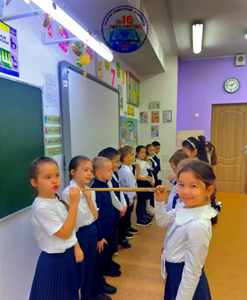 | https://www.instagram.com/reel/DA086X_NOHb/?igsh=MTdqZ2xvNG4xZW4xdw==  https://www.instagram.com/reel/DA09LfvtBPr/?igsh=M3MwZmFpZGI4cmg3  https://www.instagram.com/reel/DA2JuYICUHG/?igsh=emVjM3h3NjIyd2tn  https://www.instagram.com/reel/DA2J4Z0iz_O/?igsh=MXRsNTltZnJlZ29jZA==  https://www.instagram.com/reel/DA2J4Z0iz_O/?igsh=MXRsNTltZnJlZ29jZA==  https://www.instagram.com/reel/DA3GxBPN0zg/?igsh=MTJrMjUyenhoMXRobg==  https://www.instagram.com/reel/DA3GxBPN0zg/?igsh=MTJrMjUyenhoMXRobg==  https://www.instagram.com/reel/DBZQGHOtDsG/?igsh=MXNpMnl3ZmtmMXBkNQ==
25 | проекта “8 минут чтения | ежедневно | 2770 | 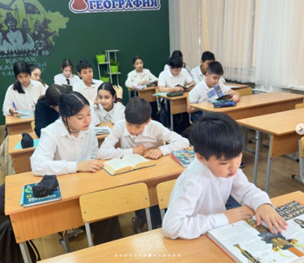 | https://www.instagram.com/reel/DA3ADEdtlH3/?igsh=MWp6bjN2azFhZndvaw==  https://www.instagram.com/reel/DA3AMYJNZTE/?igsh=YXd0YTUxajBhMW5l  https://www.instagram.com/reel/DA3Ae1htoAq/?igsh=ZGkxcjlhazVxbjJ0  https://www.instagram.com/p/DA3HIe7NS1r/?igsh=YndubDhpMHpzajZn  https://www.instagram.com/reel/DA6OQu3tQSA/?igsh=eXlxYnFsODJxeG5p  https://www.instagram.com/p/DBFz-metXwn/?igsh=cmZ4cjh1ZDRobWM1 https://www.instagram.com/reel/DBF0IXMt7cM/?igsh=MW9zbWJoM2I1ZnEx  https://www.instagram.com/reel/DBIahB_t0Dm/?igsh=MXhldmUyd2ExeThjMg== https://www.instagram.com/reel/DBMnJZ8tkLz/?igsh=bWpwcmZjeDMzcm52  https://www.instagram.com/reel/DBWvV9TNG48/?igsh=MnZ5NDA5cTkwZmht  https://www.instagram.com/reel/DBZUA6gNvvt/?igsh=MTQxYjJyN3R1OHNiOA==
26 | Экскурсия в Президентский музей | 08.10.24 | 50 | 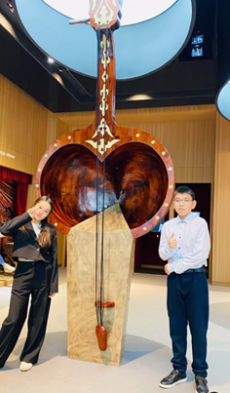 | https://www.instagram.com/reel/DA4Br_YtyPO/?igsh=MTdrdThtaGpoYXNpdA==
27 | лекция на темы: Профилактика правонарушений среди несовершеннолетних, Нахождение в ночное время без законных представителей выступила начальник ОИС УП района Байноныр капитан полиции Валиева А.Б. | 10.10.2024 | 300 | 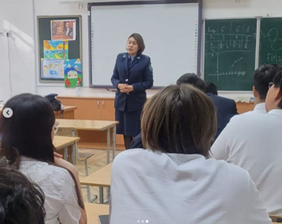 | https://www.instagram.com/p/DA98wgwCiYs/?igsh=NzhleXNjM3A1Z2wx
28 | Экскурсия памятника Кабанбай батыра | 11.10.24 | 50 | 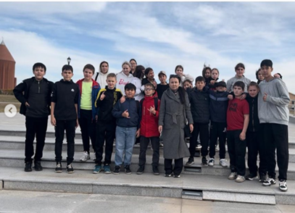 | https://www.instagram.com/reel/DA_iGh5NabI/?igsh=OGtnM3RuYTZxaXhv
29 | Торжественное мероприятие , посвященное 45-летию школы | 17.10.24 |  | 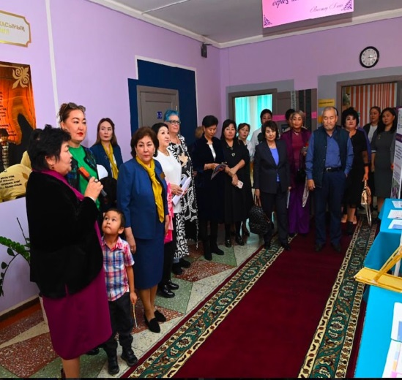 | https://www.instagram.com/p/DBS0ckZtb8V/?igsh=MXg2cDdtM3Nub3lkbA== https://www.instagram.com/reel/DBS1hHltCXO/?igsh=OW9nbWRrNWRkdmVy  https://www.instagram.com/p/DBS6Yk6tX9D/?igsh=ZXl5cmN0bDZsajVo https://www.instagram.com/reel/DBQ_vdStAha/?igsh=NmhhOGU4anBtbjN1
30 | Торжественное мероприятие , посвященное 45-летию школы | 18.10.24 |  | 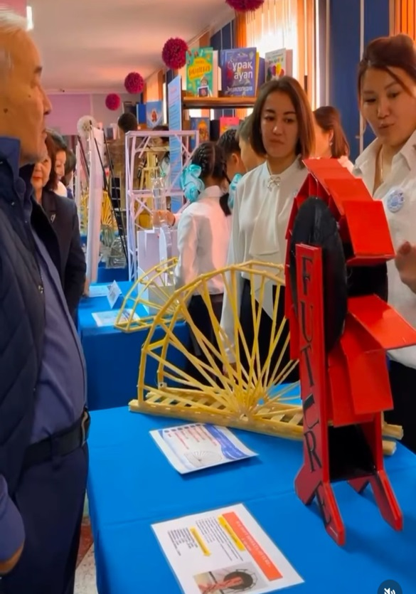 | https://www.instagram.com/p/DBS0ckZtb8V/?igsh=MXg2cDdtM3Nub3lkbA==  https://www.instagram.com/reel/DBS1hHltCXO/?igsh=OW9nbWRrNWRkdmVy  https://www.instagram.com/p/DBS6Yk6tX9D/?igsh=ZXl5cmN0bDZsajVo  https://www.instagram.com/reel/DBS7aJKAOwU/?igsh=MTNyazR2a3VhZ2oyMQ==  https://www.instagram.com/reel/DBTLR73txbD/?igsh=MXZvYXEwbG93OHZlYQ==  https://www.instagram.com/reel/DBVnbQitcr-/?igsh=MXZzaWE3eHZyODlxZA==
31 | Проект "STEM для всех" | 19.10.24 | 70 | 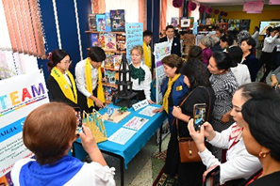 | https://www.instagram.com/reel/DBVzSIutzLh/?igsh=MXV3YTd5bmlyd3E1YQ==
32 | Классный час,посвященный Дню Республики Казахстан | 21.10.24 | 2770 | 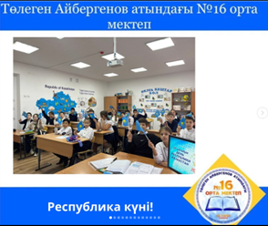 | https://www.instagram.com/reel/DBYu5Sjt1W9/?igsh=MTZod3RzbGkxYXczYQ==  https://www.instagram.com/p/DBYyQNVNhml/?igsh=Nzh3ejB5OTF1cGhi  https://www.instagram.com/p/DBY3xxxtA16/?igsh=MXJyNDlhanlqNjBoYQ==  https://www.instagram.com/reel/DBY4W7sNy_o/?igsh=bnN3bDlqZjJnMzhy  https://www.instagram.com/reel/DBZPt9oNoGd/?igsh=ZjBvcW1tMjFmNmho  https://www.instagram.com/reel/DBZQcv5t6GK/?igsh=MXJ4aTh0Ymw1cjJ5bQ==  https://www.instagram.com/reel/DBZUna4Nz9u/?igsh=MTZxajMxdzd2eGl0YQ==  https://www.instagram.com/reel/DBZV2nPNTdn/?igsh=cHA0MGkydnozOWx0  https://www.instagram.com/reel/DBZXtZGNL9s/?igsh=MXIyZWNvOHB6NjM2aQ==  https://www.instagram.com/p/DBZYehHtZAF/?igsh=d3AxeHphdDMxM3Jy
33 | Выборы Президента школьного самоуправления | 19.10.24 | 875 | 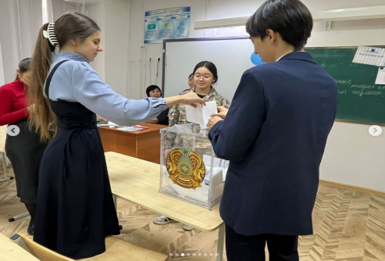 | https://www.instagram.com/p/DBbtfsotubY/?igsh=MWN6ZHhjbnNpN2U3bQ==
34 | “Час поэзии". Жизнь и творчество Сакена Сейфуллина | 24.10.24 | 50 | 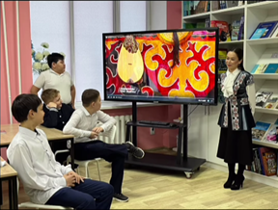 | https://www.instagram.com/reel/DBekpzRNLz0/?igsh=MXFuMGpzY3R4dmNwZw==
35 | Семейная эстафета “Папа, мама и я - в школе активная семья” | 24.10.24 | 100 | 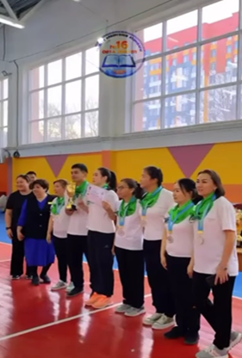 | https://www.instagram.com/reel/DBgGIY9tRdV/?igsh=MXIxd2NqYmxmYmNvZA==
36 | мегачеллендж «ТУҒАН ЕЛІМ МЕНІҢ ҚАЗАҚСТАНЫМ» | 24.10.24 | 200 | 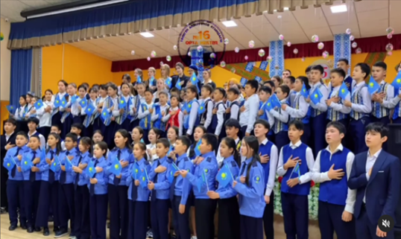 | https://www.instagram.com/reel/DBgG-W7ttbG/?igsh=MXduYTYzNnZtaWx6ZQ==
37 | Открытие класса «Жас сақшы». | 24.10.24 | 24 | 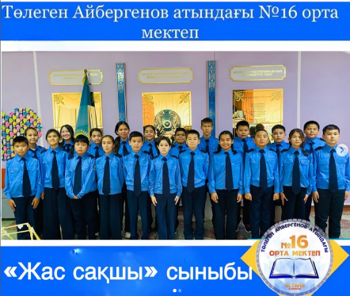 | https://www.instagram.com/p/DBhC67oOnFv/?igsh=MWQ4OHFsY3VybGE1eA==
38 | Проект « Читающая школа». Инсценировки сказок | 24.11.24 | 1050 | 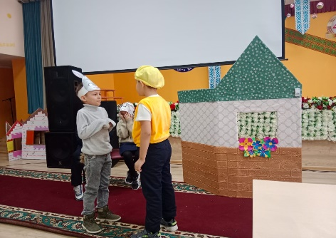 | https://www.instagram.com/p/DBhC67oOnFv/?igsh=MWQ4OHFsY3VybGE1eA==  https://www.instagram.com/p/DCrAF79Issn/?igsh=MWJoY2dyM2doNnVrYg==  https://www.instagram.com/reel/DCud0E2tHoO/?igsh=MWdsOTltNDdqdHQxOQ==  https://www.instagram.com/p/DCrAF79Issn/?igsh=MWJoY2dyM2doNnVrYg==  https://www.instagram.com/p/DCbJrpqIEtc/?igsh=MWhpaHBsMmpjdjl5dA==
39 | «Бала тәрбиесі дамуындағы басты рөл атқарушы – отбасы»-родительское собрание | 22.11.24 | 50 | 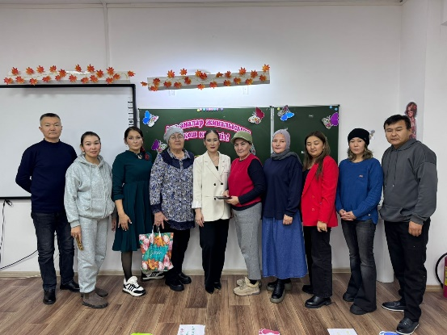 | https://www.instagram.com/reel/DCroA-5IkNb/?igsh=MWkxZGs0eGhxb3lidA==
40 | Классный час: «Профилактика правонарушений среди детей и подростков - главная задача» | 25.11.24 | 675 | 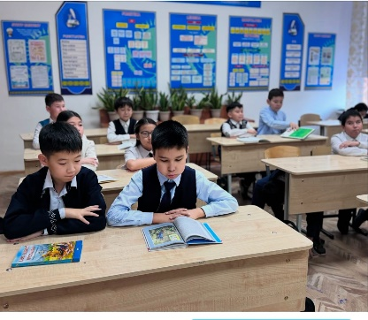 | https://www.instagram.com/reel/DCy5SVCo9iO/?igsh=MWduMnlrbWpodGF1OA==
41 | Среди учащихся 10-11 классов провел лекцию офицер управления привенции Департамента Агентства по противодействию коррупции по г.Астана Ансаганова А.А. на тему: Антикоррупционная политика. | 26.11.2024 | 150 | 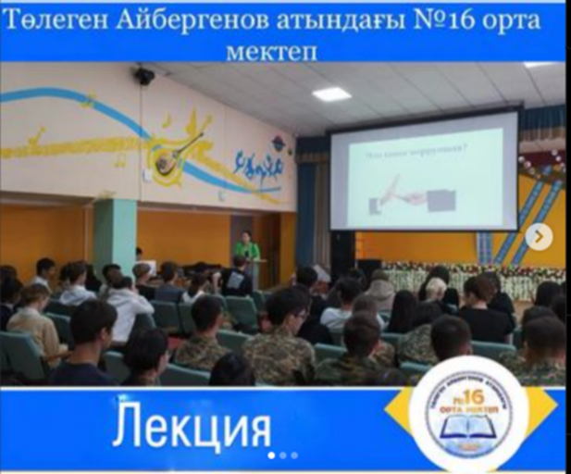 | https://www.instagram.com/p/DC0_wFHoX9t/?igsh=YjBxMDRoMXJrNGFl
42 | Майором полиции Калиакпаровой Г.Т.на темы: Правила дорожного движения и профилактика правонарушений среди несовершеннолетних. | 20.11.24 | 175 | 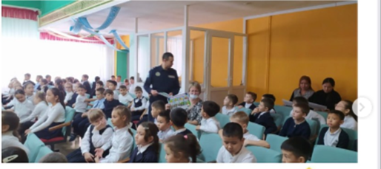 | https://www.instagram.com/p/DCntFd4NbIz/?igsh=bWthamxydjl4ZGdh
43 | Встреча с известными людьми- Оразкүл Асанғазықызы | 27.11.24 | 200 | 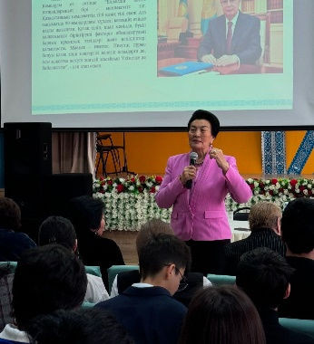 | https://www.instagram.com/reel/DC3idVWtRc0/?igsh=MWduamZtaGdsbjZtNA==  https://www.instagram.com/p/DC3yPUpo0lx/?igsh=MTR5aDF3MG5taHd6eQ==  https://www.instagram.com/reel/DC4SolcNRMV/?igsh=YWI1ZHd3amNsbHYx
44 | Классный час Тәуелсіз Қазақстанның ұлттық валютасы | 12.11.24 | 2800 | 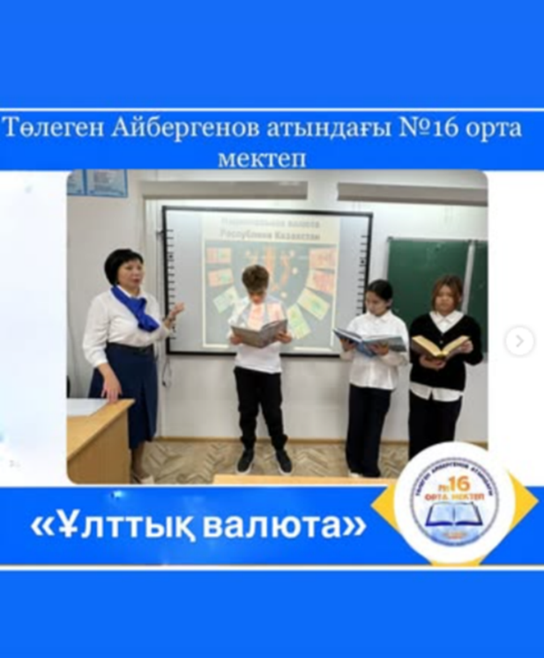 | https://www.instagram.com/p/DCOkTXTIlV9/?igsh=MWo1azBkczZ5eDUyMw==  https://www.instagram.com/reel/DCPf_S0tn3y/?igsh=c2xreHhrdmN3bjBt  https://www.instagram.com/reel/DCPf_S0tn3y/?igsh=c2xreHhrdmN3bjBt  https://www.instagram.com/reel/DCPilClNEVT/?igsh=YXliMHJ5MjZubHZn
45 | День открытых дверей для родителей 1-4 классов | 14.11.24 | 600 | 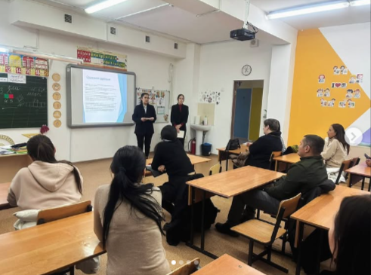 | https://www.instagram.com/reel/DCWC5FINYBE/?igsh=MXN4Zjk5N3Jxc3d2NQ==  https://www.instagram.com/p/DCW-eTyIiUL/?igsh=bHQ5bjhlbjN5c3E0
46 | В рамках проекта «Читающая школа» был проведён конкурс рисунков «Мои любимые сказки» | 18.11.24 | 150 | 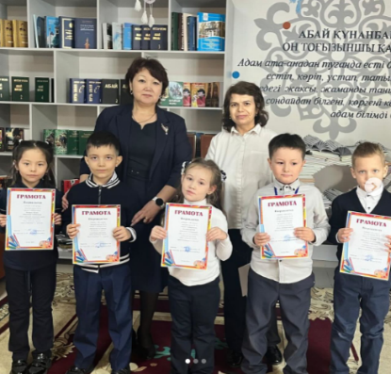 | https://www.instagram.com/p/DChXqVHIpDM/?igsh=cWR1MHowdmxyNzRs
47 | Игра по волейболу «Мы-будущее Казахстана!» | 15.11.2024 | 16 | 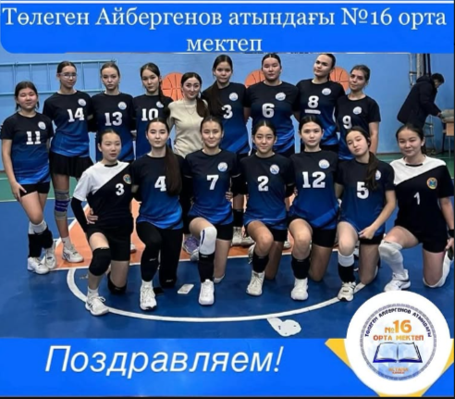 | https://www.instagram.com/p/DCZK9ZQox7A/?igsh=eHc4azJxZDVodTZr
48 | День открытых дверей для родителей 5-х классов | 14.11.24 | 150 | 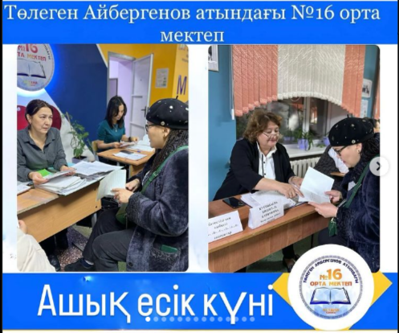 | https://www.instagram.com/p/DCW6C65ICFO/?igsh=dXY2NTh5MDQ3c3k3  https://www.instagram.com/p/DCW64KYI-Vo/?igsh=MWEzOW5ucGdiMjc3cw==
49 | Заседание дебатного клуба «Еркіндік» | 22.11.24 | 300 | 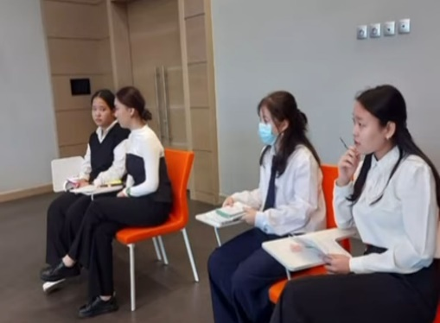 | https://www.instagram.com/reel/DCoDcNRou18/?igsh=eGFubngyaXp4ODlo  https://www.instagram.com/reel/DCqUeDVNezH/?igsh=MW9qYjlob3pxbDl1Nw==
50 | Дебаты «Ұшқыр ой алаңы» | 23.11.24 | 500 | 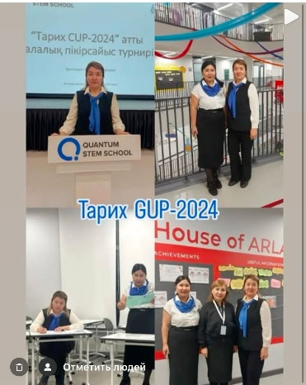 | https://www.instagram.com/p/DCr3l8nN5Yz/?igsh=MTExejYxNHJ4MGZreQ==
51 | Челлендж “Вяжем, вяжем” | 25.11.24 | 30 | 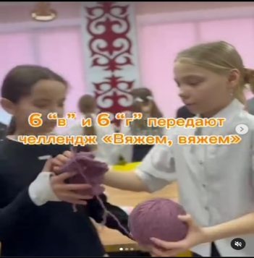 | https://www.instagram.com/p/DCzO_Xhoppa/?igsh=MW1ybTVmbDNobm0xbA==
52 | День тапочек | 03.12.24 | 1500 | 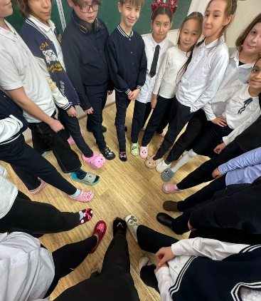 | https://www.instagram.com/p/DC8rgNGNjaz/?igsh=MWxibGpwMmpnNWtibQ==  https://www.instagram.com/p/DDH9xtYod6o/?igsh=eGJ1NjZ3dzZyc2lh  https://www.instagram.com/reel/DDIT5dutigr/?igsh=MW54eTFjd2Z0bXlodw==  https://www.instagram.com/reel/DDKUXM_Nr8D/?igsh=czc4OTE1ajBhcjZq  https://www.instagram.com/reel/DDKjFyMtdg7/?igsh=MW9yM29hYmZsM3Bybg==
53 | Дебаты «Ұшқыр ой алаңы» | 02.12.24 | 300 | 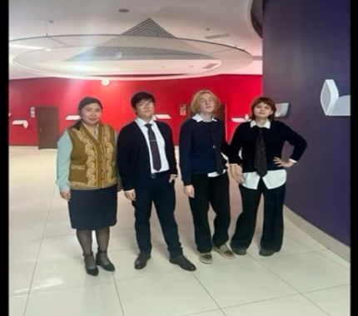 | https://www.instagram.com/reel/DDEYkHjN3Vq/?igsh=N29nYWI5ZDA0ZDQ3
54 | Лекция по профилактике правонарушения | 05-07.12.24 | 450 | 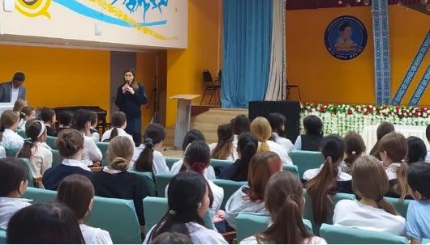 | https://www.instagram.com/p/DDFZxBeNAod/?igsh=dnhkZHZvbWU5a2E1  https://www.instagram.com/p/DDOix23NTP6/?igsh=MTlldTVhZjVya3V0cg==
55 | «Біз салауатты өмір салтын сақтаймыз» флешмоб | 06.12.24 | 80 | 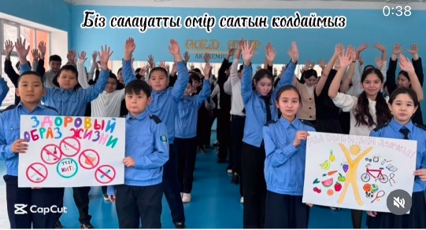 | https://www.instagram.com/reel/DDOmZwAov9n/?igsh=Z3J3Yzcxcmd3NTFy
56 | Защита STEM проектов | 06.12.24 | 70 | 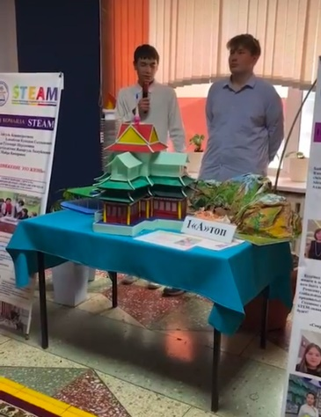 | https://www.instagram.com/reel/DDOwNwitBeb/?igsh=amVudzhkZ3FoOGVx  https://www.instagram.com/reel/DDOxC-ctvce/?igsh=cWZ3OTE2OHB5aWtl  https://www.instagram.com/reel/DDO_lYmooUC/?igsh=bDFkbTMweTc5ZGEx
57 | Спектакль, посвященный 130 летию Б.Майлина, Дню Независимости | 03.12.24 | 180 | 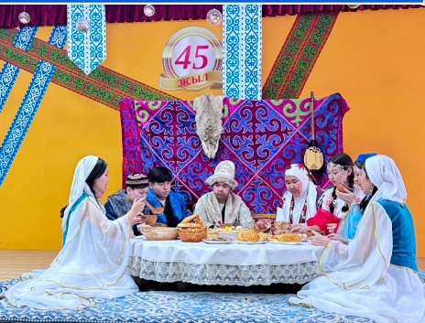 | https://www.instagram.com/p/DDH7IFlo21G/?igsh=MW51Y2d5NWplbzM5cg==
58 | Чтение живой классики на тему: «Зима». | 06.12.24 | 150 | 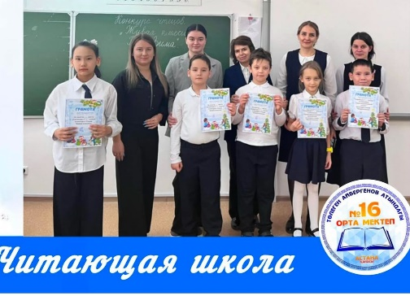 | https://www.instagram.com/p/DDO0U4-o5uf/?igsh=NG54cmticDRhcWo5
59 | Конкурс « Фото-дефиле школьной формы» | 06.12.24 | 35 | 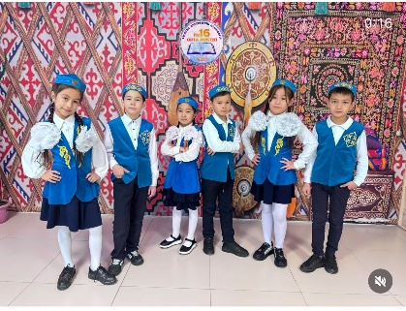 | https://www.instagram.com/reel/DDPHrcEIhza/?igsh=enhjNjNxdmJ0Ynpq
60 | Классный час «Единая Земля, единый народ, единое будущее» | 09.12.24 | 2850 | 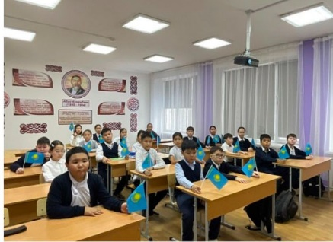 | https://www.instagram.com/p/DDW9g-BNc4x/?igsh=MzgwZTBldjZ0MGVi  https://www.instagram.com/p/DDXX6KKoGx2/?igsh=MTNud3k2MDgyZG1wbA==  https://www.instagram.com/reel/DDXdvOkN1-P/?igsh=MWg1ajRpMDdlMWs5aQ==  https://www.instagram.com/reel/DDXf1h6t11A/?igsh=NmMwdHZ0MHJjaG03  https://www.instagram.com/reel/DDXgJ4RN4gk/?igsh=MTA2dTdxNTJ6OHdhZA== https://www.instagram.com/reel/DDXlyW9tt7k/?igsh=MTh2dmNvNGsyZW1nZg==  https://www.instagram.com/p/DDXnHNBtqgv/?igsh=cmcybTM3OXBiNjNs https://www.instagram.com/p/DDgW73VthVC/?igsh=MXZsd3A4ZmNheXNoaA== https://www.instagram.com/p/DDgtfp3N7MI/?igsh=Z2Vqb2V0MzIwamx1  https://www.instagram.com/p/DDgt6twtjo7/?igsh=MXc0eW44cDdiMzR3aA==  https://www.instagram.com/p/DDgv-sJIZ8p/?igsh=c2h2Zzh0Yno4a25r  https://www.instagram.com/reel/DDhWlRuoCoL/?igsh=YnJkbmNkd284bmJq  https://www.instagram.com/p/DDodLnetQeE/?igsh=MWIyOGE2cmNhaGtlaQ==  https://www.instagram.com/reel/DDocLHENu9l/?igsh=MXdob3RwcnQyMWV6Mw==  https://www.instagram.com/reel/DDoHeSsIe1C/?igsh=ZTYyOHl0enI1MTBx  https://www.instagram.com/reel/DDoGatooOuP/?igsh=MWt0YmVwbmx5OGgxNQ==  https://www.instagram.com/reel/DDnE_Q-N42c/?igsh=N2U0d3luMzNndGp6
61 | Челлендж “ Твори добро” | 09.12.24 | 20 | 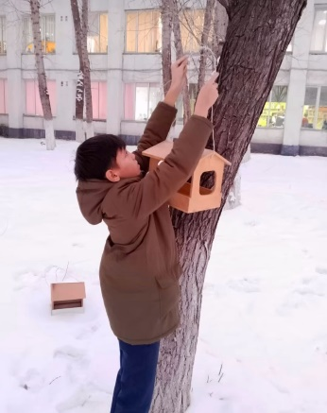 | https://www.instagram.com/reel/DDXop6WNn3B/?igsh=emhqbnBraXI2cHAx
62 | «Таза Қазақстан. Астана – тазалық пен тәртіптің үлгісі»-акция | 10.12.24 | 500 | 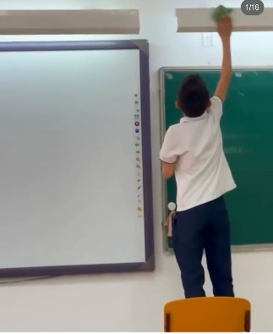 | https://www.instagram.com/p/DDZAazEtnwi/?igsh=ZXZxNzNmMnI2Ym03
63 | «Пиротехника»-лекция УИП ОЮП ОМПС УП района «Байқоңыр» Калиокпаровой Г.Т. | 10.12.24 | 30 | 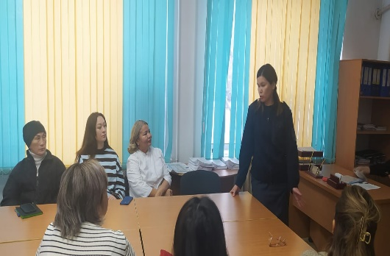 | https://www.instagram.com/p/DDeISizocNv/?igsh=MWRlbTE1bzV4aXRmbQ==
64 | Дискуссия по вопросам взаимодействия школы и семьи в вопросах предотвращения насилия | 10.12.24 | 30 | 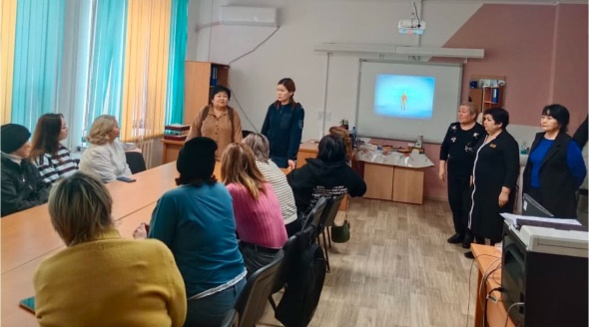 | https://www.instagram.com/p/DDbJLkmta9f/?igsh=MTlldGM1a2dkaDQ1OQ==
65 | «Детство без жестокости и насилия» начальник отдела УП р.Байконыр капитан полиции Валиева А.Б. | 12.12.24 | 175 | 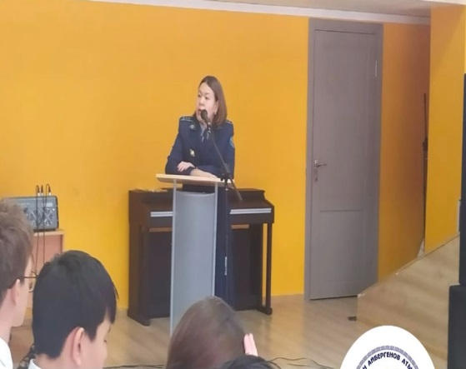 | https://www.instagram.com/p/DDeISizocNv/?igsh=MWRlbTE1bzV4aXRmbQ==
66 | «Достар шақырады» дебат турнирі | 07.12.24 | 4 | 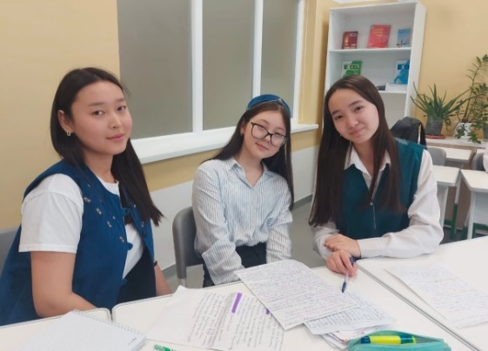 | https://www.instagram.com/p/DDeOEWloGX3/?igsh=MXVncmVtaHB0ZzhvNw==
67 | Среди учащихся 8-10 классов прошли спортивные соревнования в рамках акции «Детство без жестокости и насилия» | 11.12.24 |  | 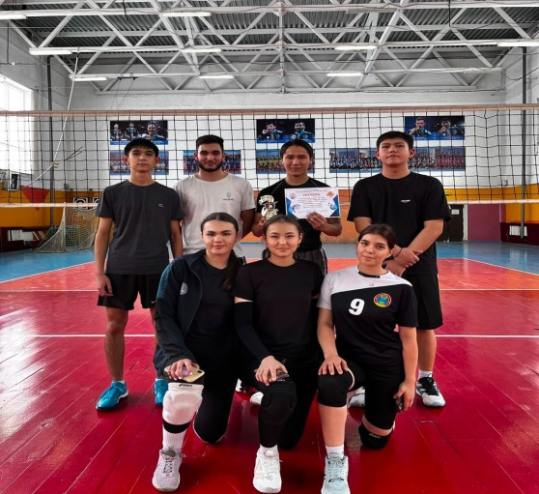 | https://www.instagram.com/p/DDedxNGIwlt/?igsh=MXd4M3Z1Z3A0bDVpdA==
68 | 16 декабря День независимости Республики Казахстан | 13-16.12.2024 | 2700 | 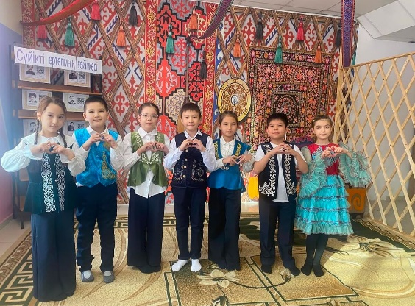 | https://www.instagram.com/p/DDgv-sJIZ8p/?igsh=c2h2Zzh0Yno4a25r  https://www.instagram.com/p/DDguxmGoAAw/?igsh=NTl1Mm9oMWRrYmN3  https://www.instagram.com/p/DDhAmwPow-P/?igsh=OWNxOWhvN3JqMmpu  https://www.instagram.com/reel/DDhFRi6I1LT/?igsh=dXJqZ2xyang2NW9x  https://www.instagram.com/reel/DDhWRqPoNc-/?igsh=MXVtdnlyZTZmcHAyOQ==  https://www.instagram.com/reel/DDhWWR0oBTB/?igsh=MW9hMXoxZW9yeGh2Yw==  https://www.instagram.com/reel/DDhWlRuoCoL/?igsh=YnJkbmNkd284bmJq  https://www.instagram.com/reel/DDhXoXXtSEL/?igsh=MWV5c20ycXM4ZnZvOQ==
69 | В начальных классах проведена акция «Бумажный бум»  2-4 классы | 13.12.2024 | 860 | 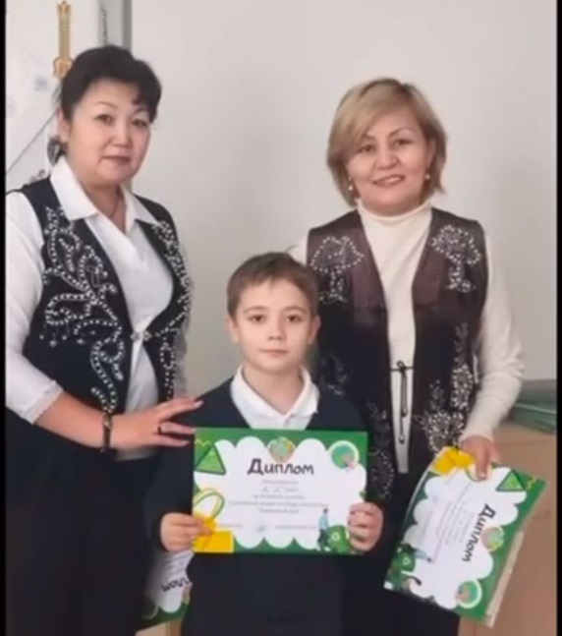 | https://www.instagram.com/reel/DDgqSymoYnA/?igsh=MTgzdGtqMGtpMWJteg==
70 | 20 декабря, в рамках проекта “Час безопасности” в нашей школе было проведено родительское собрание | 20.12.2024 | 160 | 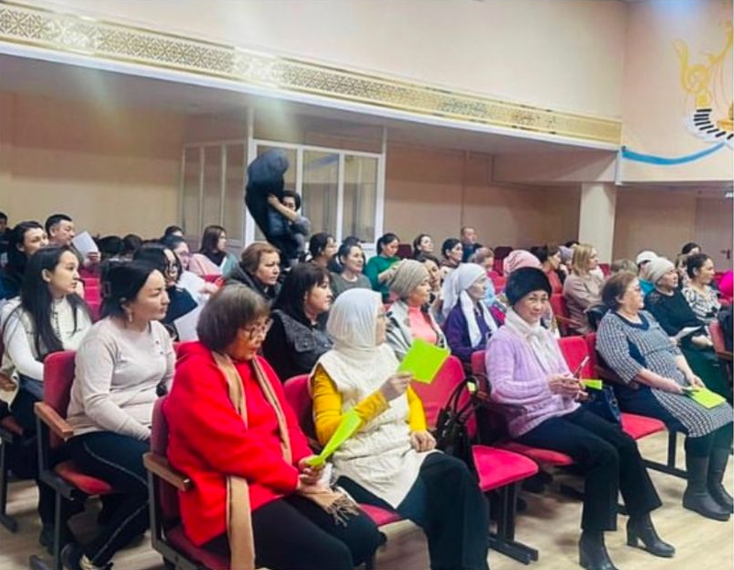 | https://www.instagram.com/p/DDzRAy_NAdH/?igsh=M284dWJjNm45ejJ5
71 | 20.12.2024 года среди учащихся 6-х классов провел лекцию по Правилам дорожного движения инспектор- дежурный Полка патрульной полиции капитан полиции Ануарбеков А.А. | 20.12.2024 | 150 | 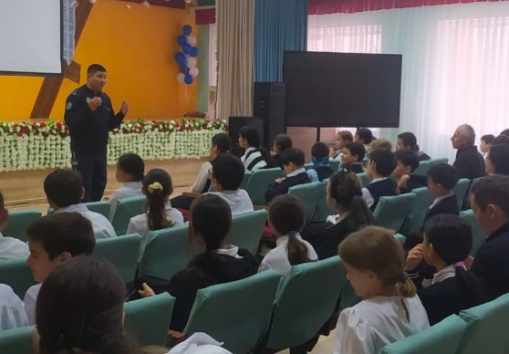 | https://www.instagram.com/p/DDzRWGvNgt9/?img_index=1&igsh=MTRkNmwwM3ZxZDJqaQ==
72 | В честь закрытия декады русского языка и литературы ученики 8 «Д» класса поставили спектакль Уильяма Шекспира «Ромео и Джульетта» | 21.12.2024 | 25 | 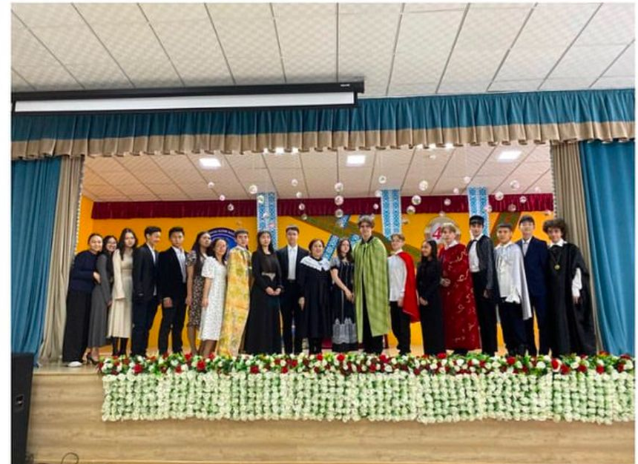 | https://www.instagram.com/p/DD09Z0PNv1q/?igsh=cXg3MnZkczhpbGE=
73 | В рамках декады учитель Амирова Дана Каримовна провела литературно-музыкальную композицию «Без Алатау мне жизни нет...» (90 - летию поэта Туманбая Молдагалиева) в 9 классах | 21.12.2024 | 60 | 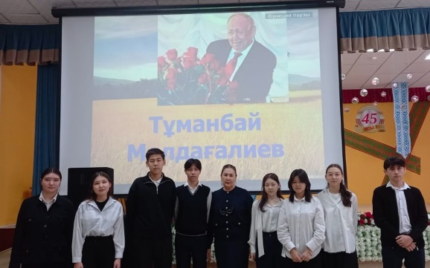 | https://www.instagram.com/p/DD13swSI1CB/?img_index=1&igsh=MW5ucXM0eGc1eDRrYw==
74 | Біртұтас тәрбие жобасы аясында, 2 “А” сынып оқушылары арасында “Әке өсиеті” және “Кім күшті” ертегілері талқыланды. | 23.12.2024 | 20 | 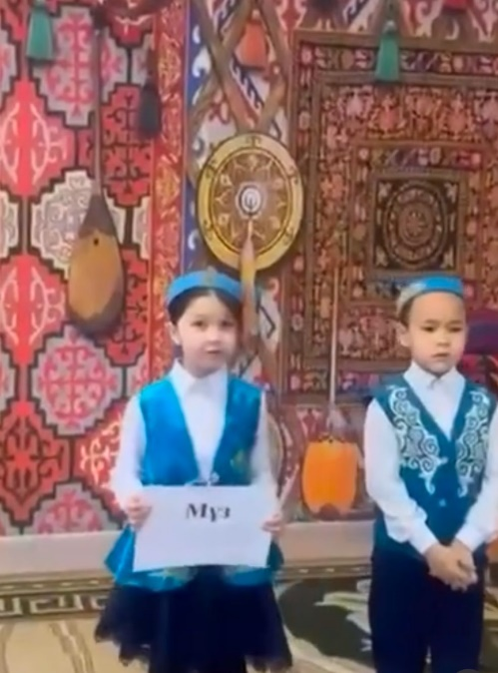 | https://www.instagram.com/p/DD7exndttoa/?img_index=1&igsh=MWxmeGFxOHFqZWZhMQ==
75 | Президенттік шырша | 25.12.2024 |  | 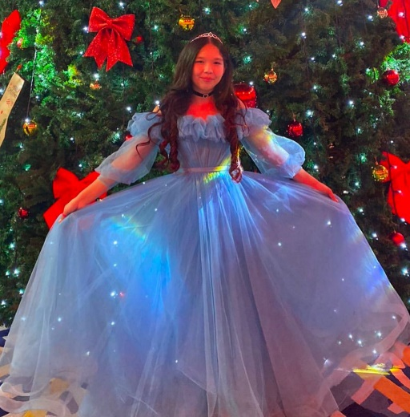 | https://www.instagram.com/p/DD-Tqk2N_ti/?img_index=2&igsh=MXFwbjdndzg1bXZ3bQ==
76 | 24.12.2024 года среди учащихся 8-х классов провела лекции начальник ОИС УП района Байконыр капитан полиции Валеева А.Б. на темы: “Правила пользования пиротехникой”, “Безопасность на льду”, “Нулевая терпимость”. | 24.12.2024 | 160 | 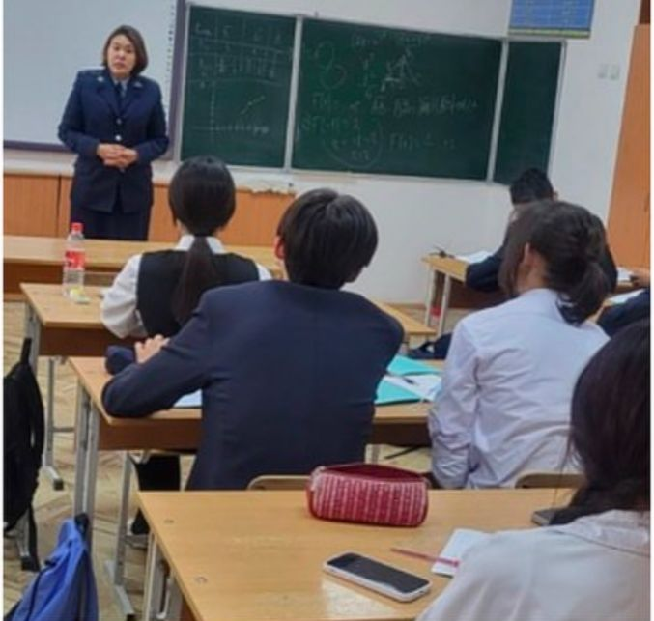 | https://www.instagram.com/p/DD-UdXCNerT/?igsh=Zzh6aHVxMzdlNmE=
77 | «Ұстаз» көркем фильмі | 11.01.2025 | 180 | 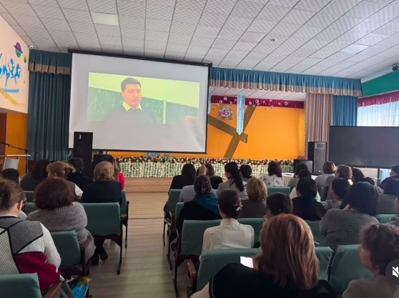 | https://www.instagram.com/reel/DErpM9ZoLlQ/?igsh=bW56cHdzbTc3NXg1
78 | Т. Айбергенов атындағы 16 орта мектебінде кіші жасөспірімдер арасында дзюдодан ашық турнир өтті. Аталмыш іс-шара Мектебіміздің 45 жылдық мерей тойына орай өткізілді. | 12.01.2025 | 280 | 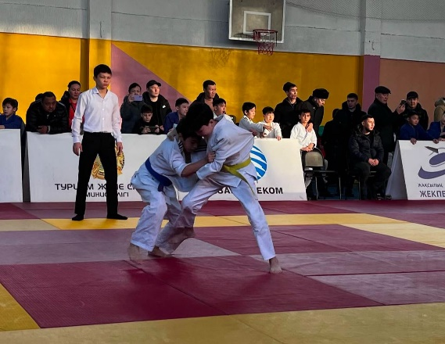 | https://www.instagram.com/p/DEuOPCOt7Sx/?img_index=3&igsh=b2JjeXBsd2RobG9y
79 | Т.Айбергенов атындағы №16 орта мектебінде 13-24 қаңтар аралығында балалар мен жасөспірімдер қауіпсіздігін арттыру мақсатында «Құқықтық сауаттылық: қауіпсіз өмірге жол» атты тақырыбында он күндік апталық басталды | 13-24.01.2025 | 2580 | 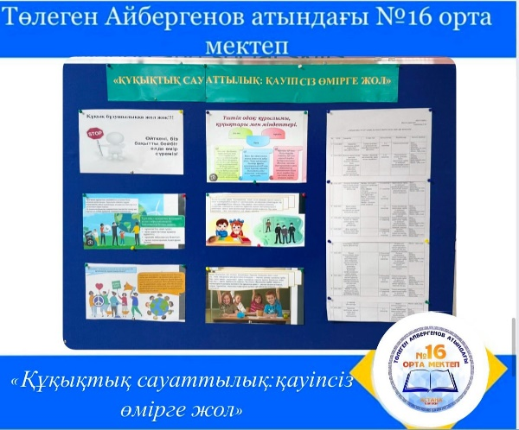 | https://www.instagram.com/p/DEwGJi-oUa5/?igsh=MXQ1b2lnMTRsNnE5NQ==
80 | Т.Айбергенов атынлағы №16 орта мектебінде 13-24 қаңтар аралығында балалар мен жасөспірімдер қауіпсіздігін арттыру мақсатында «Құқықтық сауаттылық: қауіпсіз өмірге жол» атты тақырыбында тәрбие сағаттары өтті | 13-24.01.2025 | 2580 | 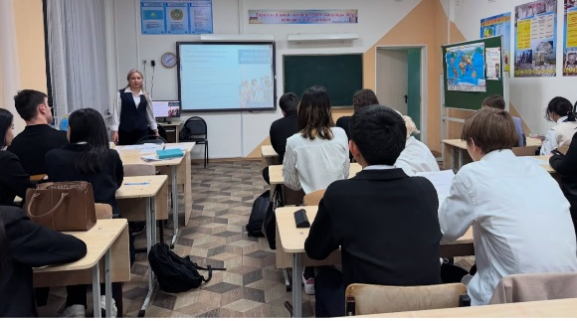 | https://www.instagram.com/p/DEwGhUSouoI/?igsh=aTRvOGZhZnN1aWl5  https://www.instagram.com/reel/DEwiFAtIGEs/?igsh=MTdjdmRwZTI1NTYyNw==  https://www.instagram.com/reel/DEwiFAtIGEs/?igsh=MTdjdmRwZTI1NTYyNw==  https://www.instagram.com/p/DEwiLtuIzoY/?igsh=MWFhOGozNHYzcHl5cA==
81 | Kiva бағдарламасы бойынша тәрбие сағаттары | 13.01.2025 | 1600 | 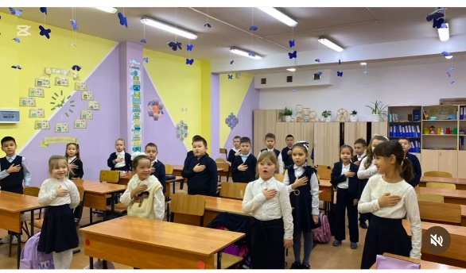 | https://www.instagram.com/reel/DEwiPb3oNHt/?igsh=MW9nem9xZzZrdjQ4Ng==
82 | Оқуға құштар мектеп 8- минуттық оқу | 13.01.2025 | 2400 | 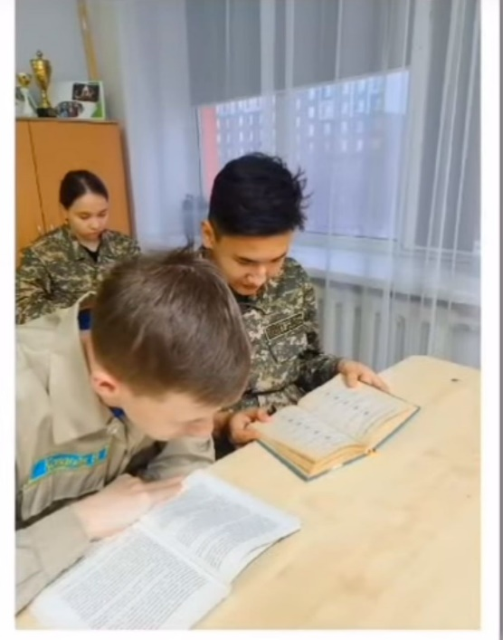 | https://www.instagram.com/reel/DEwicwfIDaq/?igsh=MXFnYm1wNnd4ZWdrdg==
83 | Қалалық «ЭкоSana» жобасын ұйымдастыру барысында «Біртұтас тәрбие» бағдарламасына сәйкес,«Таза Қазақстан» республикалық акциясын іске асырылуда | 13.01.2025 | 40 | 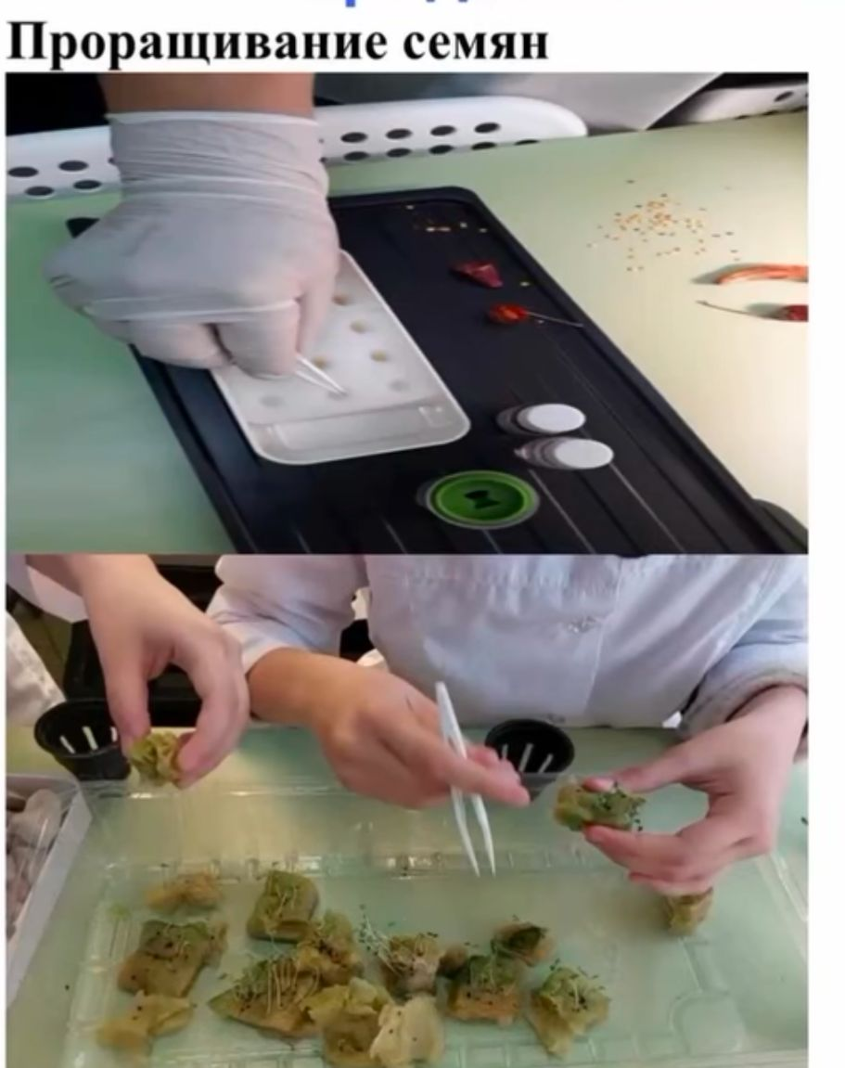 | https://www.instagram.com/reel/DEwoLj0oeTv/?igsh=MTV5dW93ZHRlOTBwYQ==
84 | 14 января психологом Макишевой А.С. и педагогом - организатором Сарсекеевой Б.А. был проведен тренинг по предупреждению и профилактике правонарушений | 14.01.2025 | 35 | 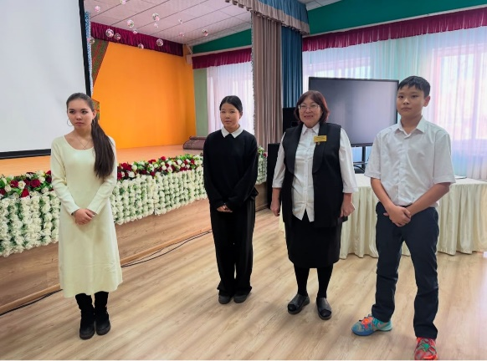 | https://www.instagram.com/p/DEz9qsWgfMq/?igsh=am5haWxqdXlzZDBk
85 | Среди учащихся 8- х классов провела лекцию инспектор ОЮП УП района Байконыр майор полиции Калиакпарова Г.Т. на темы: Правила дорожного движения, Профилактика правонарушений среди несовершеннолетних. | 15.01.2025 | 220 | 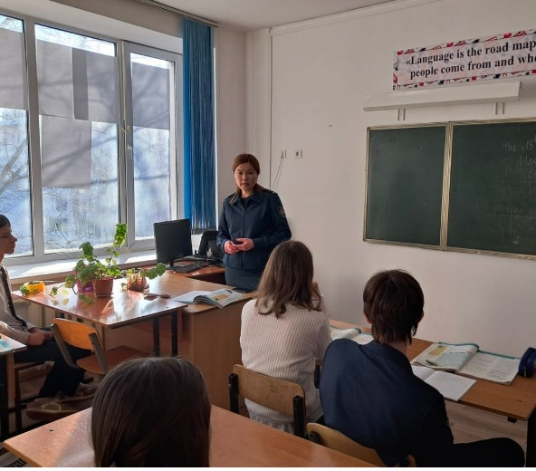 | https://www.instagram.com/p/DE19ydjos8O/?img_index=1&igsh=dnc2ZXJ5YXl3aGph
86 | 11 сынып оқушыларының ESIL университетінің өкілдерімен кездесуі өтті. Кездесуді директордың оқу ісі жөніндегі орынбасары Т.Н. Қорғанбаев ұйымдастырылды.  Кездесуде мектеп оқушылары барлық сұрақтарына жауап алды. | 14.01.2025 | 55 | 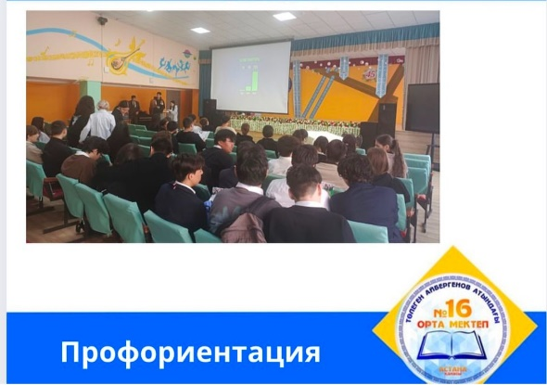 | https://www.instagram.com/p/DE4AQSnNqJV/?igsh=MXZ3NXJ4Z2RzbmFwdw==
87 | В рамках декады “Правовая грамотность: путь к безопасной жизни”, “Құқықтық сауаттылық: қауіпсіз өмірге жол”, прошел фестиваль танцев “Сделай свою жизнь ярче!”. Все участники проявили творчество, представив зрителям зажигательные танцевальные композиции. Праздник получился феерический, все участники были награждены грамотами и сладким призом. Организаторы - школьный парламент с президентом Племянниковым Григорием, и школьный психолог Макишева А.С. | 16.01.2025 | 80 | 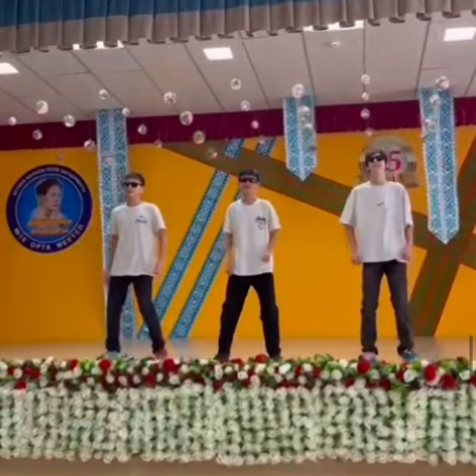 | https://www.instagram.com/reel/DE4fJxuIWpz/?igsh=MW8xeGM1ZWI5cjk5Zg==
88 | “Біз есірткіге қарсымыз”атты қойылымды 7”Ә” сынып оқушылары,ата- анамен бірге тамашалап келді. | 17.01.2025 | 22 | 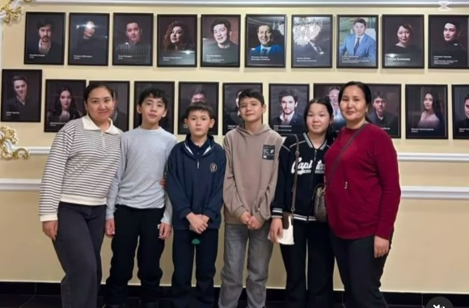 | https://www.instagram.com/reel/DFBUkF0t51D/?igsh=MWlsanNreXFxeTV4eQ==
89 | «Құқықтық сауаттылық қауіпсіз өмірге жол» онкүндігі аясында «Құқықбұзушылықтың алдын алу:«Менің ұсыныстарым» тақырыбы аясында 8-9 сынып арасында эссе байқауы өткізілді 24.01 күні нәтежиесін жариялаймыз | 20.01.2025 | 56 | 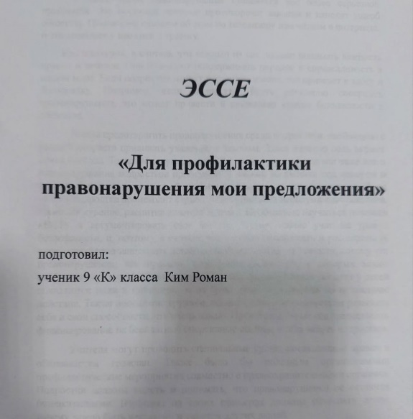 | https://www.instagram.com/p/DFCqpa6IDuU/?igsh=eHEycnprb2NtbHA1
90 | «Құқықтық сауаттылық қауіпсіз өмірге жол» онкүндігі аясында «Құқықбұзушылықтың алдын алу:«Жаяу жүргінші қауіпсіздігі күні» тақырыбы аясында Жас Сақшы сыныбы бастауыш сыныптарына тәрбие сағатын өткізді | 20.01.2025 | 55 | 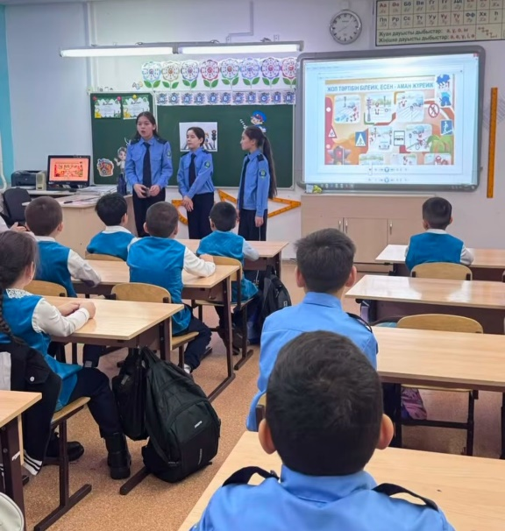 | https://www.instagram.com/reel/DFC34dVo3nr/?igsh=dzZ2bnpxaDBxa3kx
91 | «Құқықтық сауаттылық қауіпсіз өмірге жол» онкүндігі аясында «Қауіпсіздік бізден басталады тақырыбы аясында бастауыш сынып оқушылары сурет салды | 20.01.2025 | 120 | 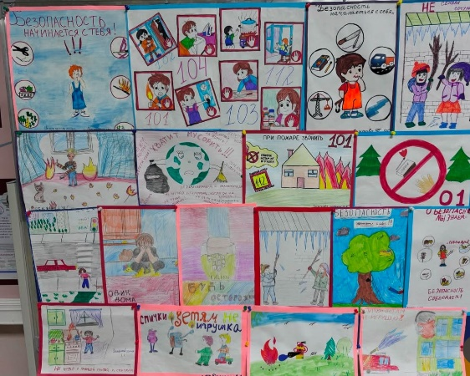 | https://www.instagram.com/p/DFDQyt6Ilz4/?igsh=MWFqdTAzdnEzYnB2eA==
92 | В рамках программы “KiVa” мы провели классный час на тему “Онлайн и оффлайн буллинг”. | 21.01.2025 | 25 | 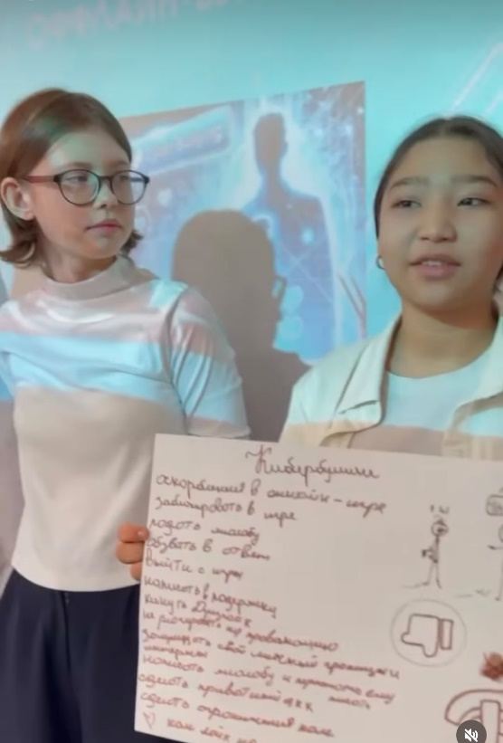 | https://www.instagram.com/reel/DFD3IpXN5PA/?igsh=MWlqcWlzd3pmc3Rhaw==
93 | Среди учащихся 9 классов провела лекцию старший о/у УПН ДП г. Астаны подполковник полиции Рахимова Л.Г. на тему: Профилактика наркотических средств и прекурсоров среди несовершеннолетних. | 21.01.2025 | 230 | 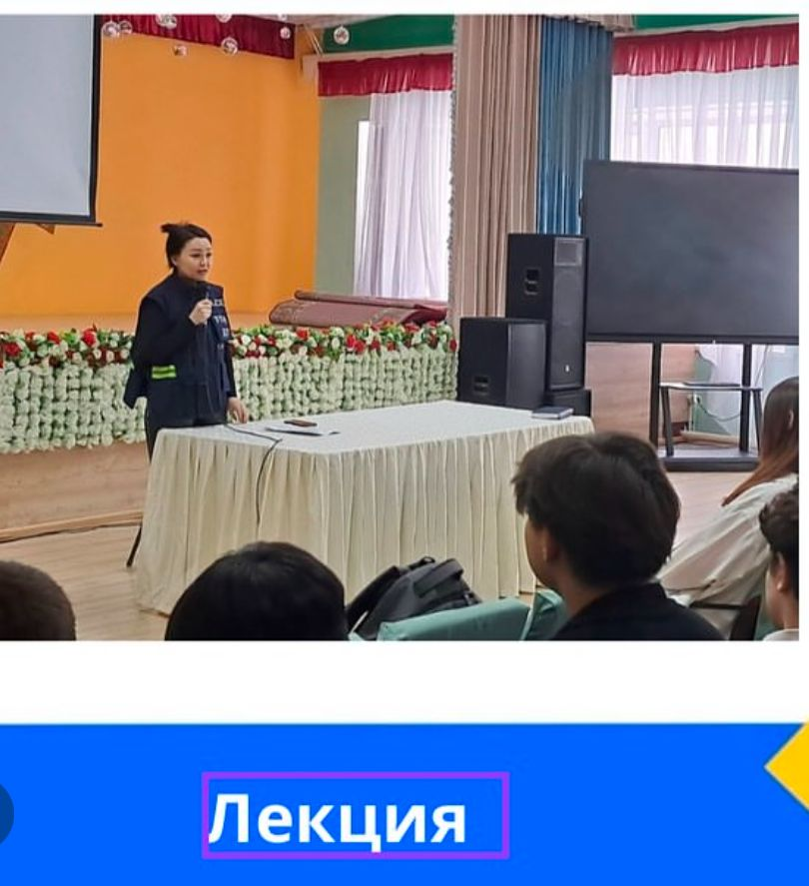 | https://www.instagram.com/p/DFFColDtKGC/?igsh=Z3hmemR6bThsMnc1
94 | На параллели 3 классов прошёл классный час на тему «Детство без насилия». | 21.01.2025 | 180 | 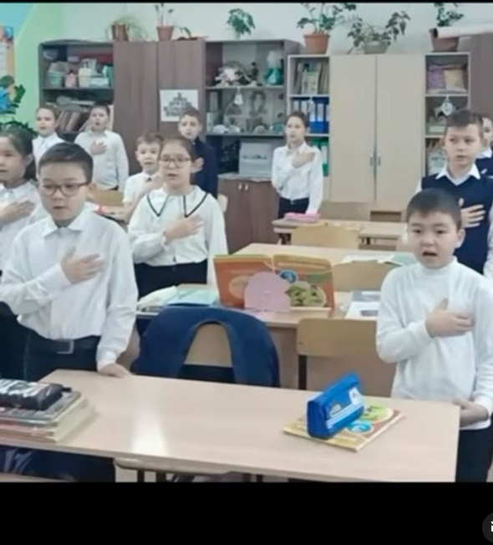 | https://www.instagram.com/reel/DFFsPcPIybt/?igsh=aXd5MmZqM3BscTcw
95 | Таза Қазақстан акциясы . Мектебіміздің ер мұғалімдері мектеп ауласын қардан тазалады. | 24.01.2025 | 22 | 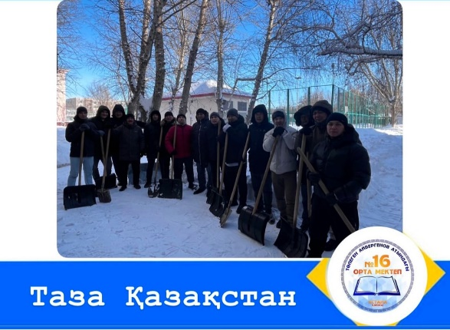 | https://www.instagram.com/p/DFNzp2aIMpf/?igsh=a3ViZHFtcmxrZ3Nr
96 | В целях профилактики правонарушений среди несовершеннолетних в 9 «Н» классе прошел классный час на тему:«Подросток и закон» и урок безопасности: «Мошенничество в онлаин шопинге». | 27.01.2025 | 25 | 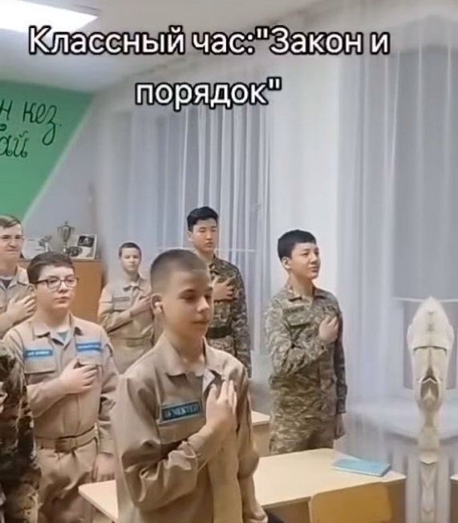 | https://www.instagram.com/reel/DFVNuBjIWdz/?igsh=Mm9nc252YmsyOXlo
97 | УП района Байконыр капитан полиции Валиева А.Б.. Ознакомила родителей с видами мошенничества, связанными с переводами денежных средств через карточки несовершеннолетних. А так же лекции на темы « Закладки. Административные и уголовные правонарушения среди несовершеннолетних». Перед родителями выступила Жудурукова Асем Каиратовна - врач педиатр поликлиники №8. Которая рассказала о том, что важна иммунизация ВПЧ девочек. В конце собрания родители задавали вопросы и получали квалифицированные ответы. | 28.01.2025 | 260 | 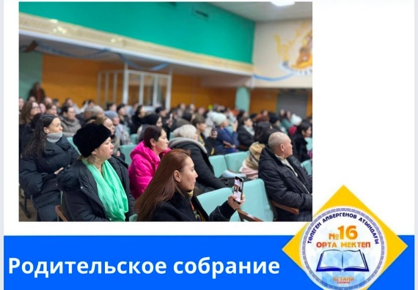 | https://www.instagram.com/p/DFXNUwhN_8R/?igsh=bnY0NHE1Z2sxdXB2
98 | Астана қаласы Мектепішілік және студенттік Парламентінің «Қар десанты» еріктілер эстафетасы. | 28.01.2025 | 44 | 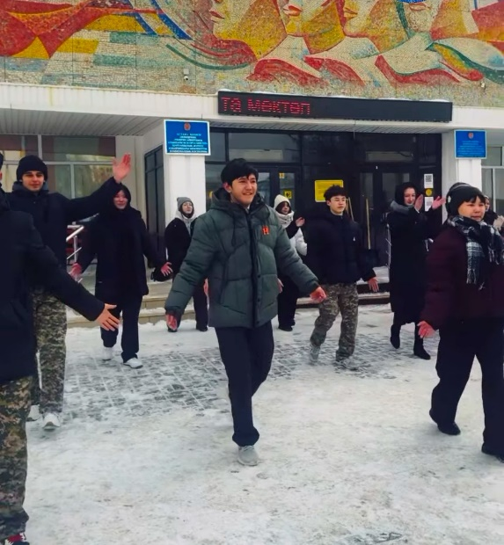 | https://www.instagram.com/reel/DFXOGefIxV5/?igsh=MXRyajc3cWFyMmp5ZA==
99 | Мектебімізде 8-сынып оқушыларының қатысуымен қазақтың қайсар батыры, от ауызды ақыны, әділдік пен адамдықты ту еткен біртуар тұлға Махамбет Өтемісұлының 220 жылдығына орай “Махамбет-тәуелсіздік жаршысы” тақырыбында ашық іс-шара өтті. | 29.01.2025 | 58 | 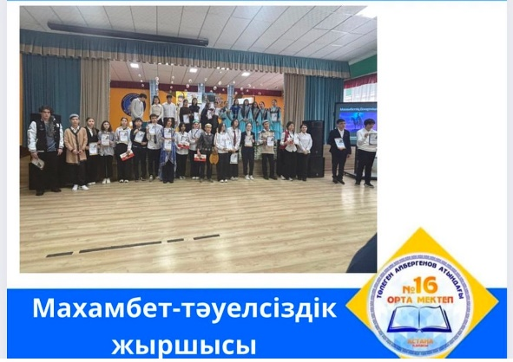 | https://www.instagram.com/p/DFaQzxNtyyH/?igsh=MjZmc2l3ZWJyMmJx
100 | “ҚҰҚЫҚТЫҚ САУАТТЫЛЫҚ:ҚАУІПСІЗ ӨМІРГЕ ЖОЛ” онкүндік аясында өткізілген “ҚҰҚЫҚ БҰЗУШЫЛЫҚТЫҢ АЛДЫН АЛУ:”МЕНІҢ ҰСЫНЫСТАРЫМ”эссе байқауына белсене қатысқандары үшін мараппаталды | 30.01.2025 | 30 | 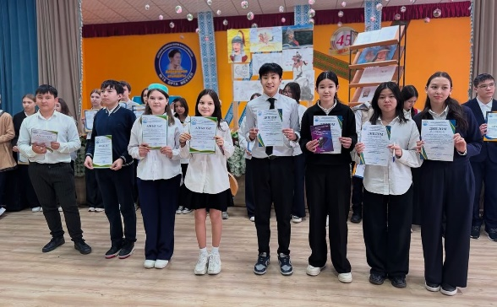 | https://www.instagram.com/p/DFb3pTTIT53/?igsh=MTdhaTdtOWR3ZXgycw==
101 | Мектебімізде 8-сынып оқушыларының қатысуымен қазақтың қайсар батыры, от ауызды ақыны, әділдік пен адамдықты ту еткен біртуар тұлға Махамбет Өтемісұлының 220 жылдығына орай “Махамбет-тәуелсіздік жаршысы” тақырыбында ашық іс-шара өтті. | 30.01.2025 | 58 | 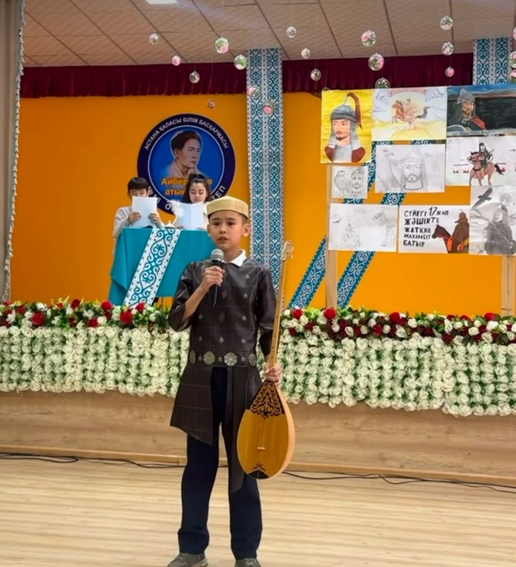 | https://www.instagram.com/reel/DFb7-flITu9/?igsh=MXJuZzN1ZzJ5amg3Zg==
102 | Мектебімізде ұйымдастырылған «Ашық есік» күні жетістікке жетелеген игі шара болды. | 30.01.2025 | 280 | 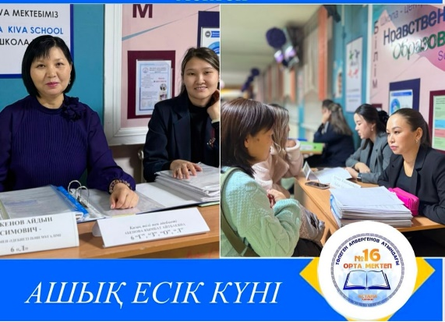 | https://www.instagram.com/p/DFdEIwdoQi2/?igsh=dmtwdTBnZmE1YXN3
103 | Прошли родительские собрания на параллели 4х классов. | 31.01.2025 | 140 | 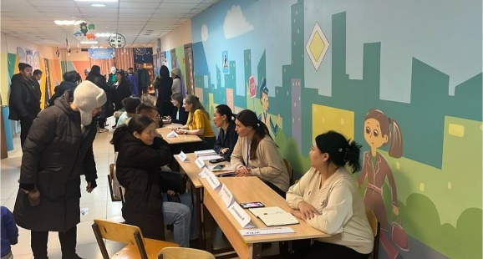 | https://www.instagram.com/p/DFfsZGNIYif/?img_index=3&igsh=MXJtajgyNjl4Z3VzbQ==
104 | На параллели 3-х классов прошла выставка рисунков на тему: «Безопасность начинается с себя» | 03.02.2025 | 55 | 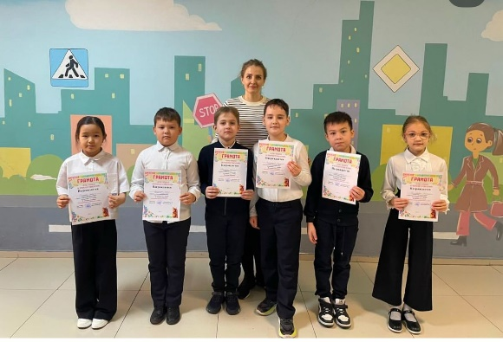 | https://www.instagram.com/p/DFmzuUBoRSU/?img_index=2&igsh=ODZuam1iZWx0enFr
105 | В 1-ых классах прошел классный час «Урок совместного чтения» в рамках антибуллинговой программы KiVа. | 04.02.2025 | 134 | 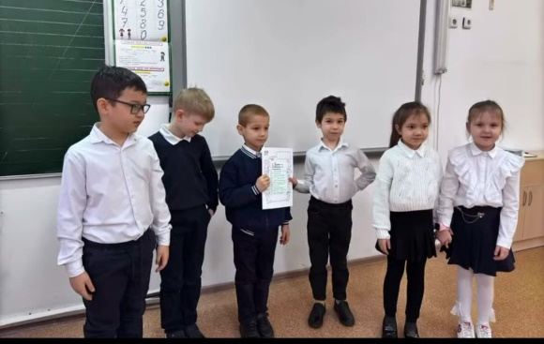 | https://www.instagram.com/reel/DFoe62-oFt4/?igsh=eTFlZDUxZHg5emV1
106 | Мектебімізде көрнекті ғалым, тілші, әдебиет зерттеушісі Телжан Шонанұлының 130 жылдығына орай арнайы шара өтті! | 04.02.2025 | 35 | 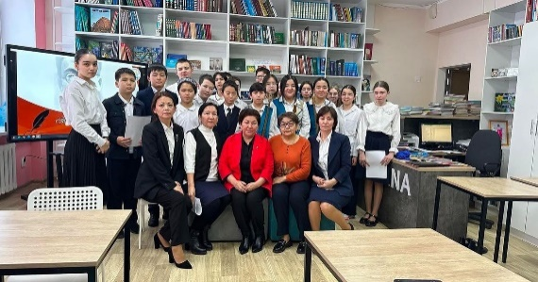 | https://www.instagram.com/p/DFqWlUct2SU/?img_index=1&igsh=ZWs5MHNqcG5yNTg3
107 | Прошли родительские собрания на параллели 1-х классов. | 06.02.2025 | 120 | 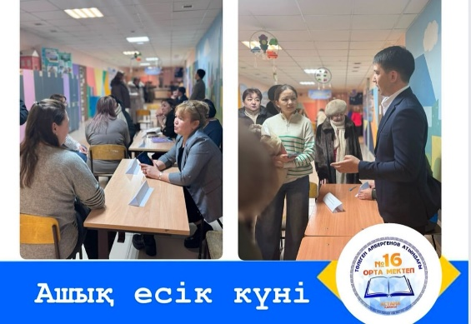 | https://www.instagram.com/p/DFwiCYNooTE/?igsh=cG50emN4Ymc4d3Mx
108 | Әліппемен қоштасу | 08.02.2025 | 50 | 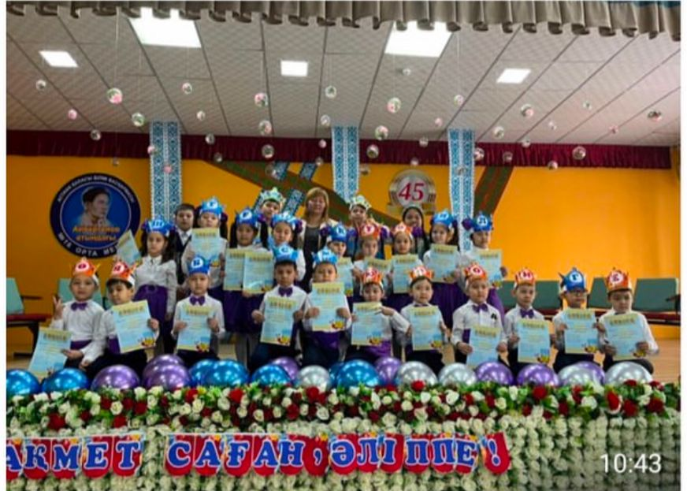 | https://www.instagram.com/p/DF0mVg3tNf4/?igsh=MWhuYzRpb2E3cW4zMA==
109 | Среди учащихся 5-6 классов провел лекцию о/у уголовного розыска УП района Байконыр капитан полиции Рәпілбек Н.М. на тему: Профилактика правонарушений среди несовершеннолетних. | 10.02.2025 | 330 | 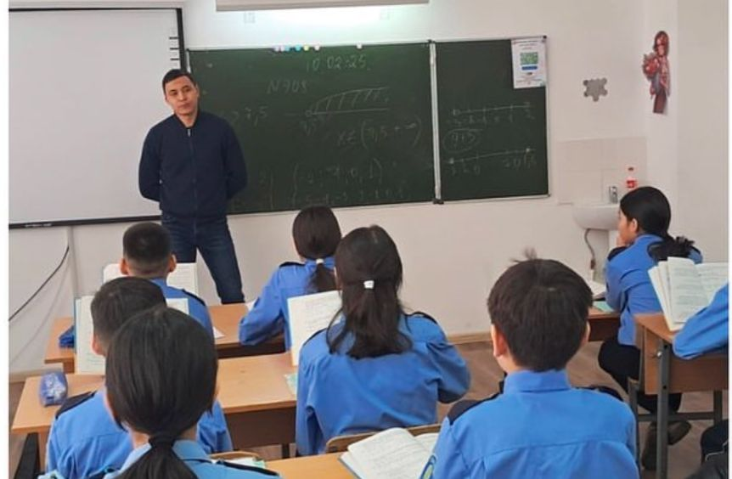 | https://www.instagram.com/p/DF4nE7StH-w/?igsh=anhob2FvZWJmNTho
110 | Среди учащихся 8-х классов провела лекцию старший о/у УПН ДП г.Астаны подполковник полиции Рахимова Л.Г. на тему: Профилактика наркотических средств и прекурсоров среди несовершеннолетних. Закладки. Показан видеоматериал. | 10.02.2025 | 260 | 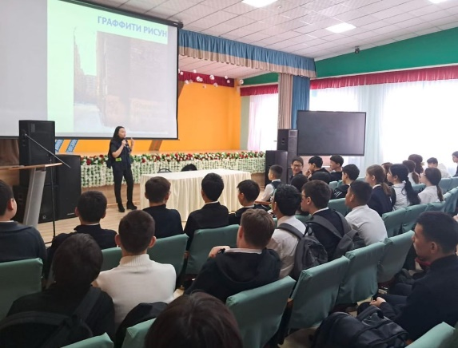 | https://www.instagram.com/p/DF4nWAutvy3/?img_index=3&igsh=MTJ5ZXRjdXE4bHp1Zg==
111 | Мектебімізде 11-сынып оқушыларына арналған кәсіби бағдар беру кездесуі өтті. Кездесуге Азаматтық қорғаныс академиясының 4-курс курсанты, қатардағы Ботахара Мұхамед-Хали Мейірбан және директордың оқу ісі жөніндегі орынбасары Қорғанбаев Т.Н. қатысып, оқушыларға болашақ мамандық таңдау жолында маңызды ақпараттар берді. | 11.02.2025 | 80 | 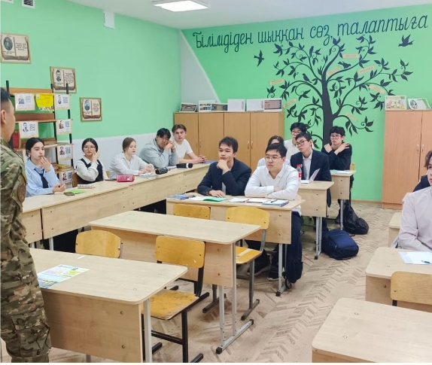 | https://www.instagram.com/p/DF7N0TZNkbg/?img_index=1&igsh=MXU5ZHE5c3FvN242MQ==
112 | Жас сақшылар Ikomek109 орталығында | 12.02.2025 | 25 | 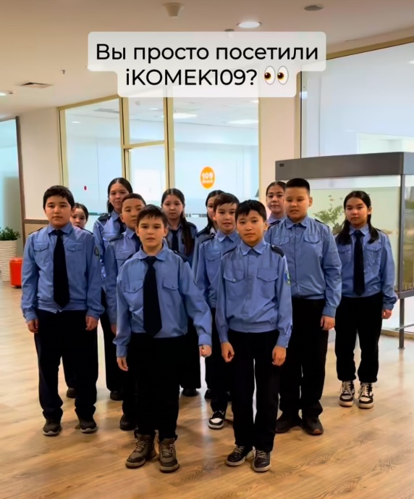 | https://www.instagram.com/reel/DF-UQuXMded/?igsh=MXB5NmtqNDB5aWRsaA==
113 | Прошли родительские собрания на параллели 3-х классов | 13.02.2025 | 130 | 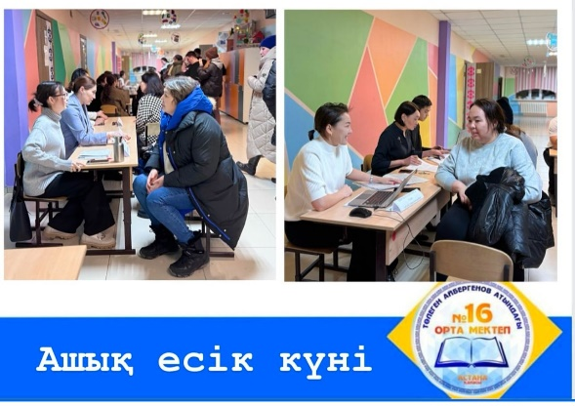 | https://www.instagram.com/p/DGBBHlZofGm/?igsh=MXA2bnhpOTh2ajljZQ==
114 | Халықаралық кітап сыйлау күні | 14.02.2025 | 2400 | 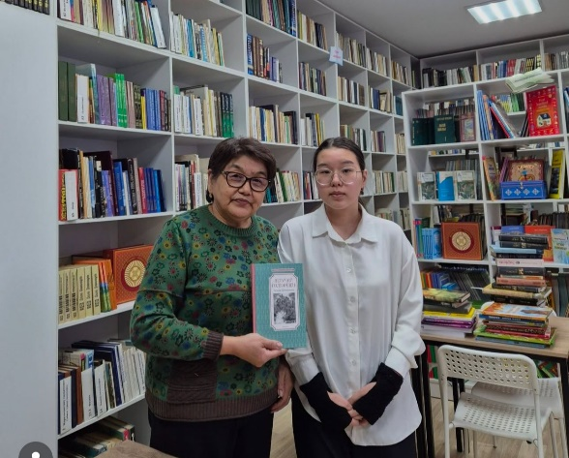 | https://www.instagram.com/p/DGDTz3Ror_2/?igsh=d3Qxcm94ODNqZ3Vt  https://www.instagram.com/reel/DGDX9MrtNGB/?igsh=NGRhZGs0NnJmM2pn  https://www.instagram.com/p/DGDYMEbNTfD/?igsh=MW5vaHplMDYxMzJiNQ==  https://www.instagram.com/reel/DGDbKtyNzlx/?igsh=MTZzNG1iMHcxZDJ2aw==  https://www.instagram.com/reel/DGDcOnnN4NI/?igsh=MTg2bndxdGVwOWU0Yg==  https://www.instagram.com/p/DGDnZNXonth/?igsh=d3Y4MjFsenkwYmJj  https://www.instagram.com/reel/DGDo9jVtS1i/?igsh=YjJ3Z3ZsZzVvenpk
115 | В рамках акции “Таза Қазақстан” наша школа учавствует в конкурсе снеговиков “QAR FEST” | 14.02.2025 | 12 | 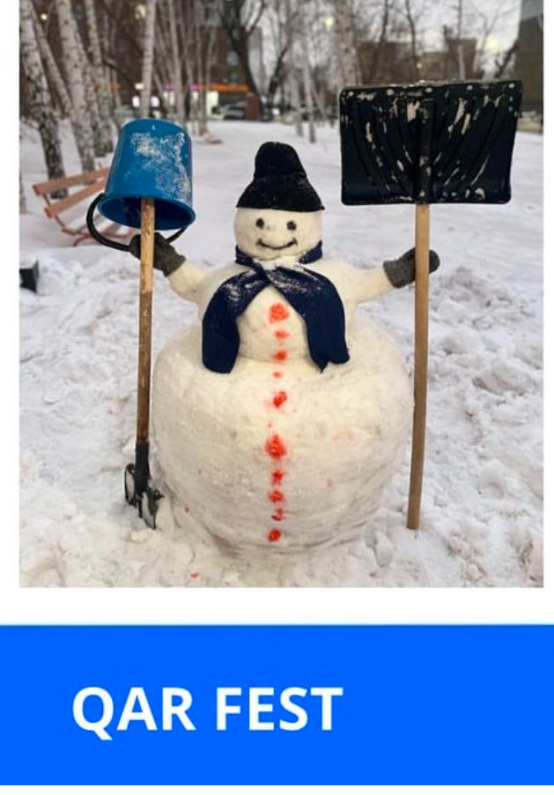 | https://www.instagram.com/p/DGDf8CzN9iC/?igsh=MTU5Y3l6d3h5MWZ0eQ==
116 | Мектеп парламенті көңілді үзіліс ұйымдастырды. «Көңілді үзіліс». | 14.02.2025 | 12 | 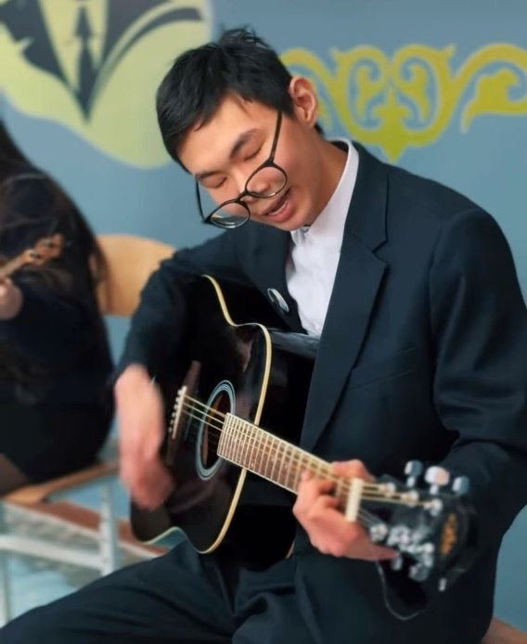 | https://www.instagram.com/reel/DGDvbN-opNv/?igsh=ZGUycjJjMzEzdnlx
117 | Мектеп парламентінің жиналысы. Алдағы іс-шараларға жоспар құрудамыз. | 14.02.2025 | 16 | 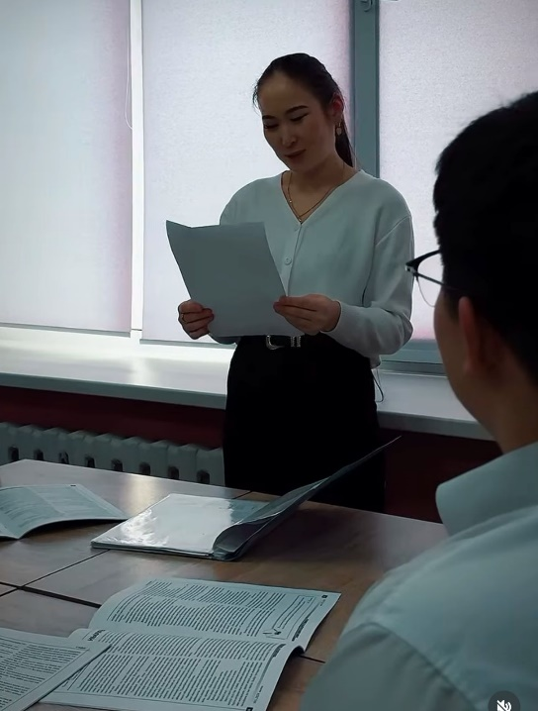 | https://www.instagram.com/reel/DGDv4HNIZ6w/?igsh=MXdxaGx6NmdpNWwybg==
118 | Таза Қазақстан жобасы аясында бастауыш сынып оқушылары тластиктен құстарды тамақтандыратын ыдыстар жасап әкелді. Табиғатты аялайық. | 15.02.2025 | 85 | 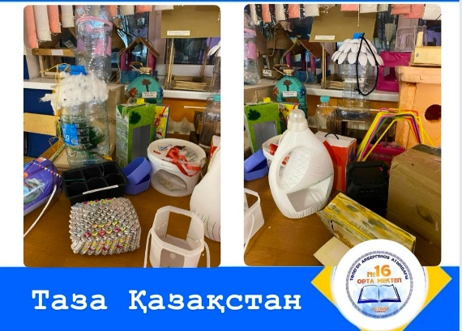 | https://www.instagram.com/p/DGFO9uUItOx/?igsh=MWx2Ym96dm44NnlvYg==
119 | На параллели 3-х классов прошел конкурс «Кормушки из подручного материала» | 20.02.2025 | 140 | 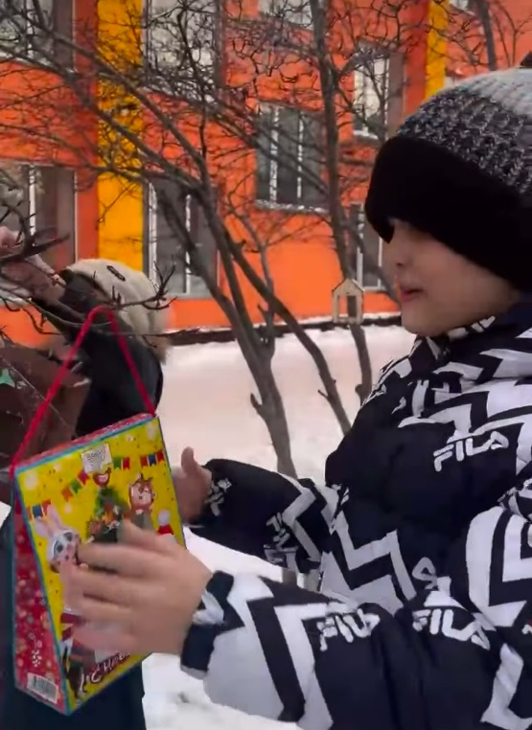 | https://www.instagram.com/reel/DGSIoMHoqp_/?igsh=OHRhZnBiaDJqMGVi
120 | Прошли родительские собрания на параллели 2-х классов. | 20.02.2025 | 115 | 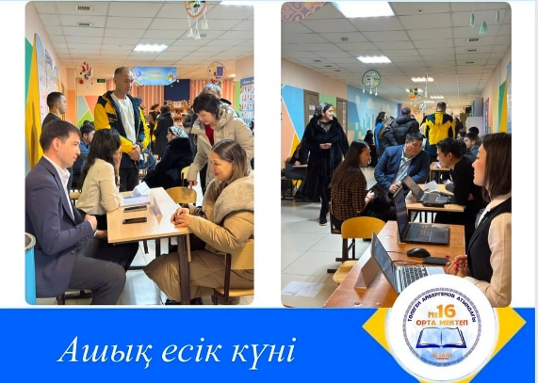 | https://www.instagram.com/p/DGTI714IqX9/?igsh=MTFjNG5tOTUydnoybA==
121 | Среди учащихся 9-х классов провели лекции медработники поликлиники 8 психолог Сагиева И.К., врач-уролог Есенжан Н.Т., врач-акушер гинеколог Смаилова Л.К. на тему: Береги себя: важные шаги в поддержании репродуктивного здоровья и личной гигиены. | 21.02.2025 | 160 | 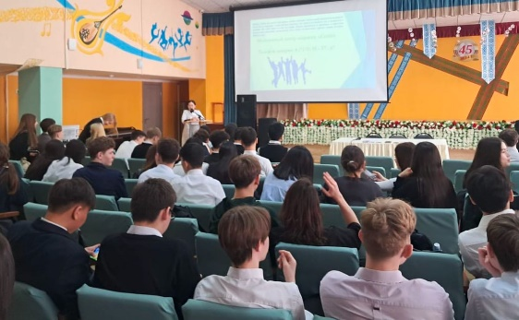 | https://www.instagram.com/p/DGU49BQNY68/?img_index=1&igsh=cmdwZzRiaWk0YzN5
122 | В школе торжественный день, мы открыли Уголок Славы, посвященный памяти младшего лейтенанта милиции Евгения Владимировича Конта и младшего сержанта юстиции Павлова Сергея Павловича героически погибших в 1997 году спасая жизни детей. | 21.02.2025 | 25 | 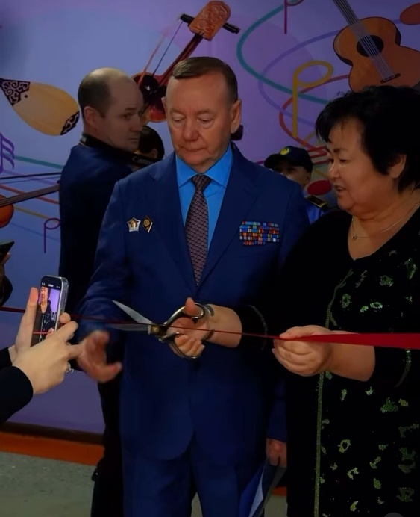 | https://www.instagram.com/reel/DGVT4efoiOT/?igsh=Mm9kbzdoMXZiajFr
123 | Мектебімізде үлкен және айтулы оқиға. Біз 6 «А» сынып оқушыларын жас сақшылар қатарына қабылдадық. Ант қабылдаған полиция полковнигі Қанат Әскербекұлы Жұмағалиев . Жас сақшы сынып оқушыларына жас сақшы куәлігін табыстады. | 21.02.2025 | 45 | 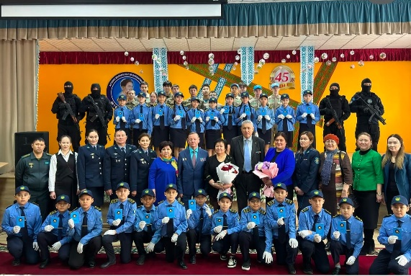 | https://www.instagram.com/p/DGVcEcioSXE/?igsh=ZGdodHZtNnB0MXEw
124 | Дүниежүзілік Азаматтық қорғаныс күні айлығы аясында “Азаматтық қорғаныс-халықтың қауіпсіздігіне кепілдік” ұранымен ашық есік күні | 23.02.2025 | 70 | 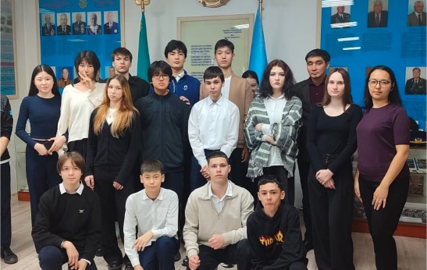 | https://www.instagram.com/p/DGaUihuNC73/?igsh=eGR5Z2lwMnVycWF0
125 | Еліміздің маңызды мерейтойының бірі - Қазақстан халқы Ассамблеясының 30 жылдығына орай "Менің Отаным - Қазақстан" атты сынып сағаты өтті. | 24.02.2025 | 2400 | 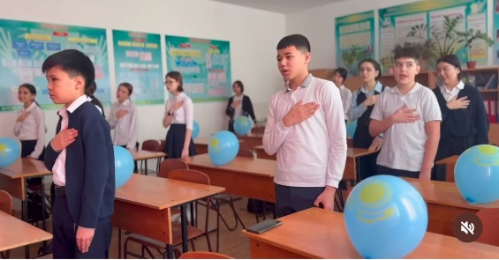 | https://www.instagram.com/reel/DGc5pq1Mebx/?igsh=MTY0ZWlmMWMwYW12eA==  https://www.instagram.com/reel/DGdtRFwtFF_/?igsh=OGM2OGF5NW1qNm9i  https://www.instagram.com/reel/DGdr79BtAPe/?igsh=MWlpbzdqbnI3aHZjOQ==  https://www.instagram.com/reel/DGdpJXcIqjw/?igsh=a243cWU2a3h6N3Iw
126 | Мектеп әкімшілігінің кәсіптік бағдар беру жоспарына сәйкес 2025 жылғы 25 ақпан күні Астана қаласы ТҚ Департаментінің №17 өрт сөндіру бөлімшесіне 10 «А», 10«Б», 10«В», 10«Г», 6 «А» сынып оқушылары экскурсияға барды | 25.02.2025 | 85 | 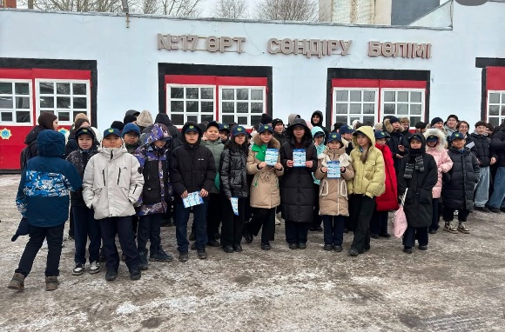 | https://www.instagram.com/p/DGgNNAao78w/?igsh=MXBvZ2w2N3ZqN2d6eQ==
127 | Алғыс айту күні | 01.03.2025 | 2560 | 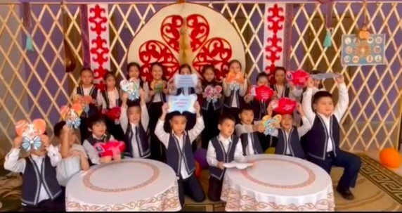 | https://www.instagram.com/reel/DGnU9mPoM2Z/?igsh=MWFjNHRhOGo4cGNuZg==  https://www.instagram.com/reel/DGnWHowITRt/?igsh=d3E0YnR3bXRwYW15  https://www.instagram.com/reel/DGpfn8Mt4zK/?igsh=eHdpdnptaWtuZGZt
128 | Қалибек Куанышбаев атындағы қазақ ұлттық музыкалық драма театрына саяхат. | 01.03.2025 | 7 | 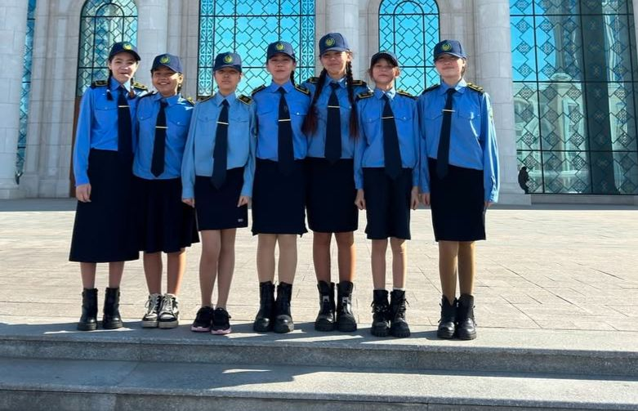 | https://www.instagram.com/p/DGpf88UoB_E/?igsh=MWNreWxtNjB5amVlcw==
129 | Среди учащихся 3-4 классов провела лекцию инспектор ОЮП УП района Байконыр майор полиции Калиакпарова Г.Т. на тему:Правила дорожного движения. Правила поведения в школе. | 05.03.2025 | 330 | 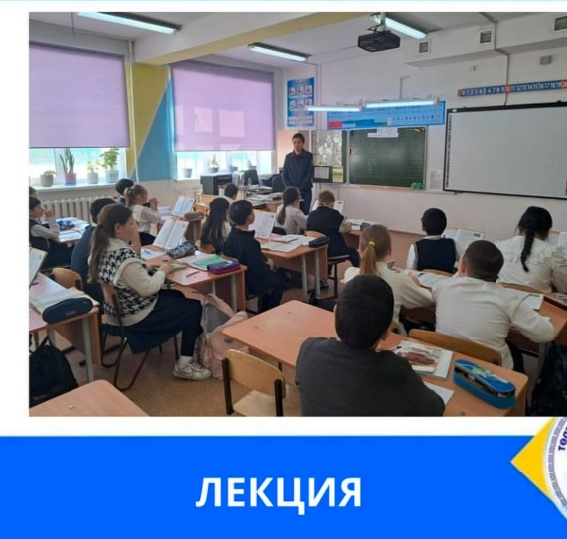 | https://www.instagram.com/p/DG2g6S3N8Ob/?igsh=MWdycndjM24yZDJy
130 | «Ананың аялы алақаны» челлендж | 06.03.2025 | 1800 | 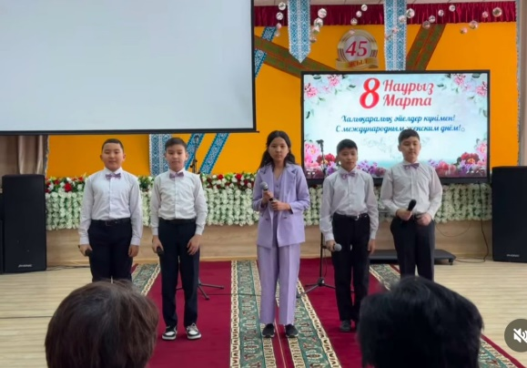 | https://www.instagram.com/reel/DG2ku0ioJ6A/?igsh=cTlueTNoZnBnbXBz  https://www.instagram.com/reel/DG2p8lMsuwA/?igsh=aHlrbm05NHVoYTh0  https://www.instagram.com/reel/DG2qYpgARlk/?igsh=Y3A5N2Q5bW4zM3Yw  https://www.instagram.com/reel/DG2qZzbA_hN/?igsh=ajVzMzZlYTRmc3I1  https://www.instagram.com/reel/DG2qa59gLGO/?igsh=dm5wbDJlMm9yaDZr  https://www.instagram.com/reel/DG2rZF9gFvm/?igsh=eHY2YTBhdmtuMTZz  https://www.instagram.com/reel/DG2sPxHgkL7/?igsh=MWV3NGhhM3NoeWFkdw==  https://www.instagram.com/reel/DG2sdt3gagz/?igsh=ZjNsM3RveWFsc2ph
131 | Біртұтас тәрбие бағдарламасы аясында қолөнер | 06.03.2025 | 170 | 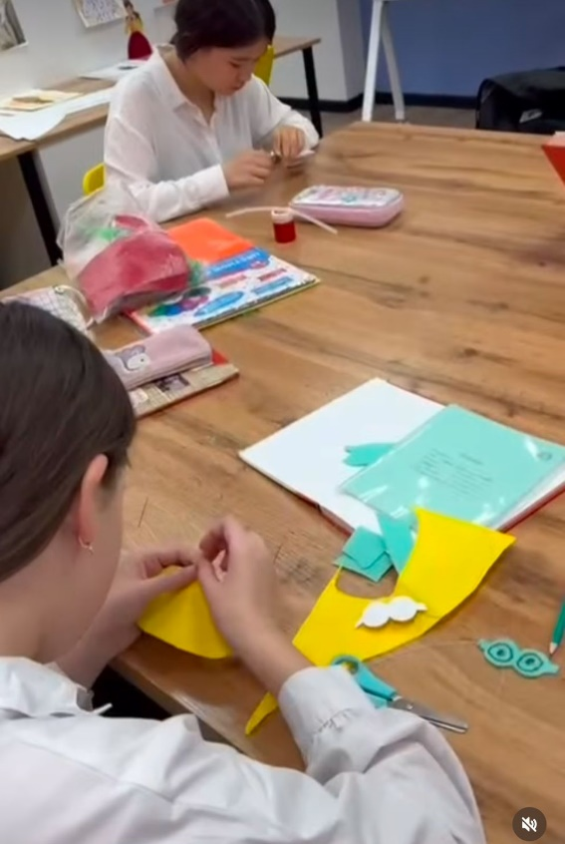 | https://www.instagram.com/reel/DG3GveNAiLc/?igsh=dWJ3eXdlZjlieW53
132 | Наурыз айының жетінші жұлдызында мектебімізде 8-9- сынып оқушылары (Т2)”Құлагер” поэмасы бойынша сахналық қойылым көрсетті. | 07.03.2025 | 130 | 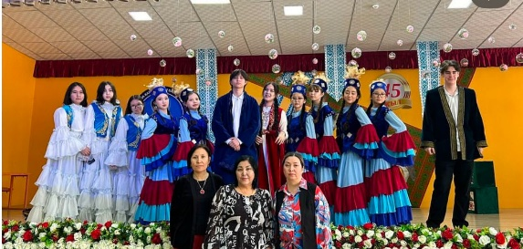 | https://www.instagram.com/p/DG52KLhts58/?img_index=1&igsh=MW5tNWZ4b3IzaHZ3MQ==
133 | Қазақ халқында қыз балаға ерекше көңіл бөлінген, оның тәрбие алуына, ұяңдық пен ұқыптылыққа баса назар аударылған. «Бұрымды» деген сөз қыздың сұлулығын, әдептілігін және тәрбиелігін білдіреді. | 07.03.2025 | 60 | 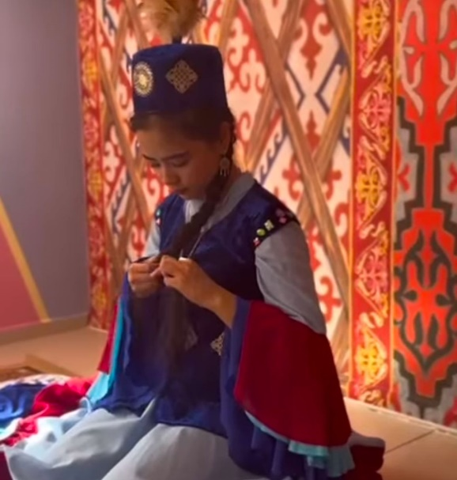 | https://www.instagram.com/reel/DG8a4pqoYDo/?igsh=MThkcDB1NnpwdjR5ag==
134 | В рамках экологической акции "Час Земли" учащиеся 9 И, 9В, 9 К классы провели конкурс фотографий под названием "Селфи с природой!". | 13.03.2025 | 80 | 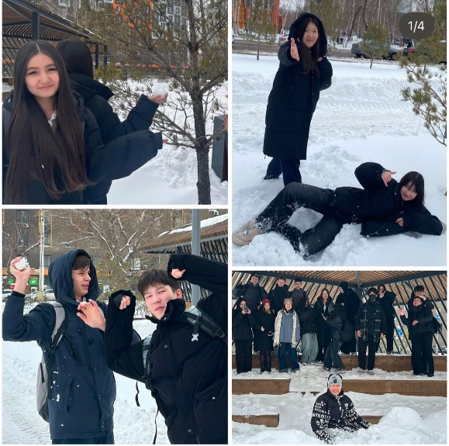 | https://www.instagram.com/p/DHIOCQSIn7L/?igsh=eGg1b3JsZnNlZ3ow
135 | Көрініс: “Шахмат пен Тоғызқұмалақ – ақыл-ой ойыны” | 13.03.2025 | 28 | 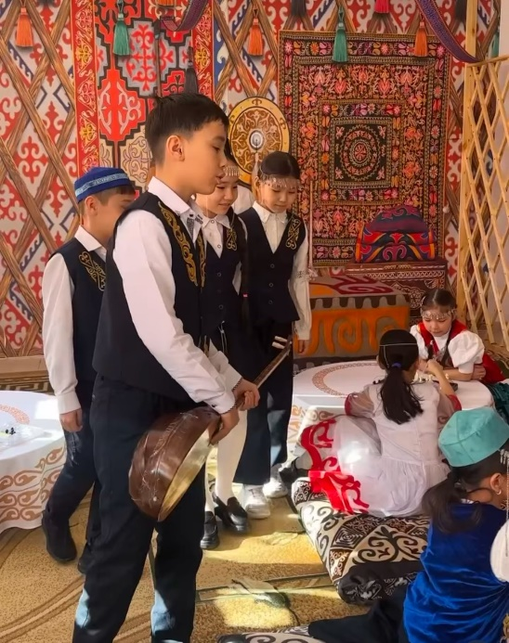 | https://www.instagram.com/reel/DHI1TUht7g5/?igsh=MTQwY3k2aTBwZGQzdQ==
136 | Ерекше қажеттіліктері бар балаларды қолдау – біздің ортақ міндетіміз! | 15.03.2025 | 15 | 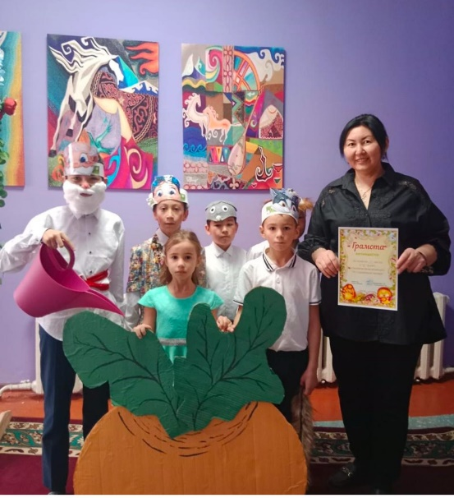 | https://www.instagram.com/p/DHNs_G7IXE_/?igsh=azRzM2lwMTF1dGM=
137 | “Шаңырақ күні” - символ материального и духовного наследия казахского народа. Ученики 4Б класса под школьным шаңырақом за дружбу и единство всех народов Казахстана! 🇰🇿 Кл.рук-ль Салтанат Серикбаевна | 17.03.2025 | 2300 | 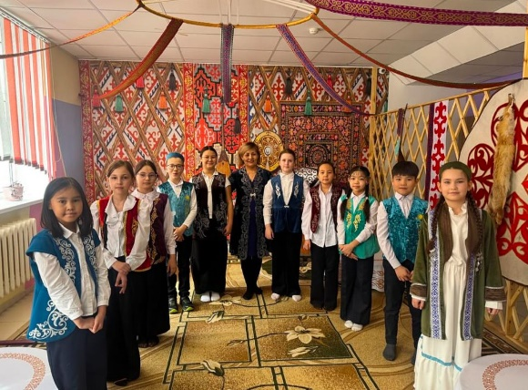 | https://www.instagram.com/p/DHTiayJIF9Z/?igsh=MWY0dHVxeXFqNThxMA==
138 | Мектепте ұйымдастырылатын тағамдар жәрменкесі | 17.03.2025 | 1500 | 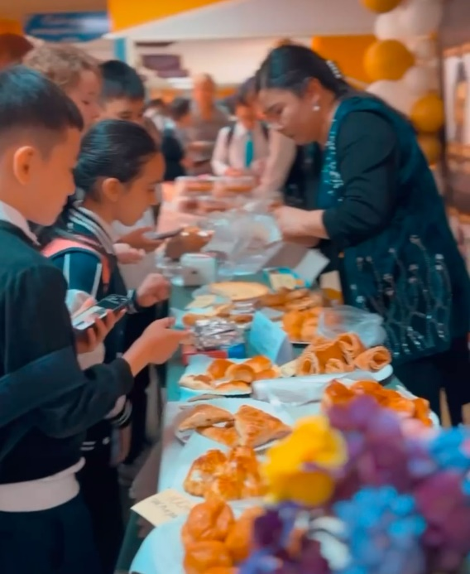 | https://www.instagram.com/reel/DHTtiXQoCsK/?igsh=MWdqd3Bnemkwc25tZA==  https://www.instagram.com/reel/DHTt5IpIcZ9/?igsh=aWNxZ2szZThoamxt  https://www.instagram.com/p/DHUCcweIT2X/?igsh=MXZuZXVyMXlhdmFyYw==
139 | Родительское собрание в 5 Д классе классным руководителем Бисембаевой У.З. и инспектором ОЮП УП района Байконыр майором полиции Калиакпаровой Г.Т. на тему Час безопасности : Буллинг и Административные правонарушения среди несовершеннолетних. | 18.03.2025 | 25 | 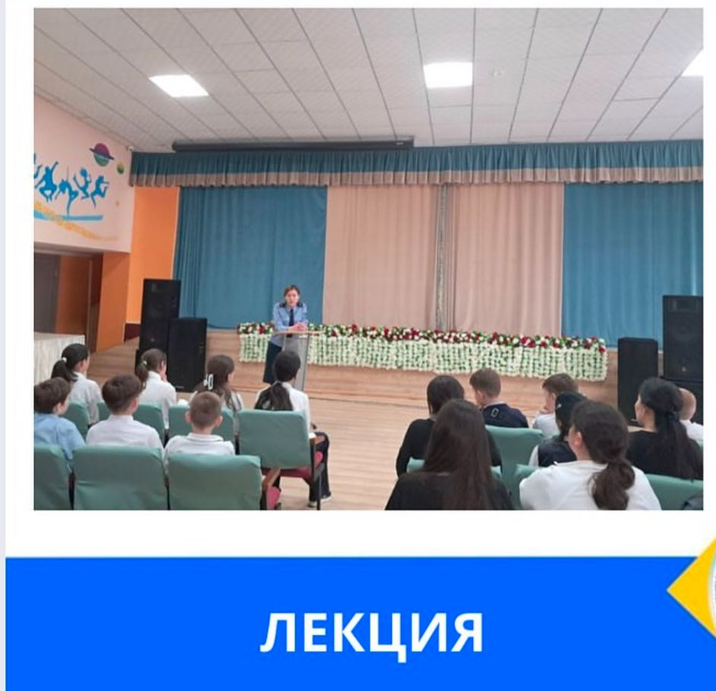 | https://www.instagram.com/p/DHVglE_MCTp/?igsh=MW8zNHVnZGNmYjhzdQ==
140 | 18 Наурыз тарихи күн болып жазылды.  Астананың төрінде Үш мың қыр гүліндей қызғалдақтар жайқалды.  Қазақтың Әз-Наурыз Ұлыстың Ұлы күні қарсаңында рекорд орнатты! | 18.03.2025 | 22 | 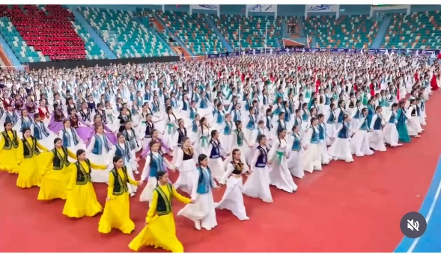 | https://www.instagram.com/reel/DHWKlg1In_n/?igsh=ZTZ4M2xpbDl5bHZ6
141 | Мектепішілік дебаттық іріктеу турнирі өткізілді.  Дебат турниріне 8-9 сыныптар қатысты. | 17.03.2025 | 15 | 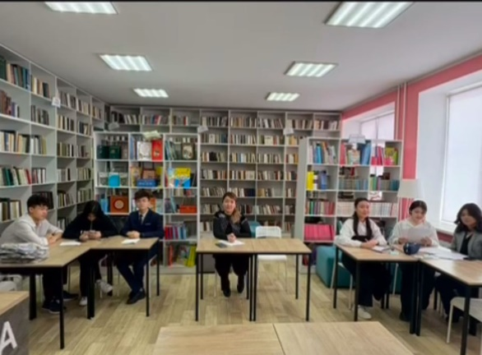 | https://www.instagram.com/reel/DHaVWfsIK5O/?igsh=MTdkdW1wOWFsZ3NiZw==
142 | Прошли день национальных видов спорта (улттык спорт) где приняли участие параллель 5 классов. | 20.03.2025 | 250 | 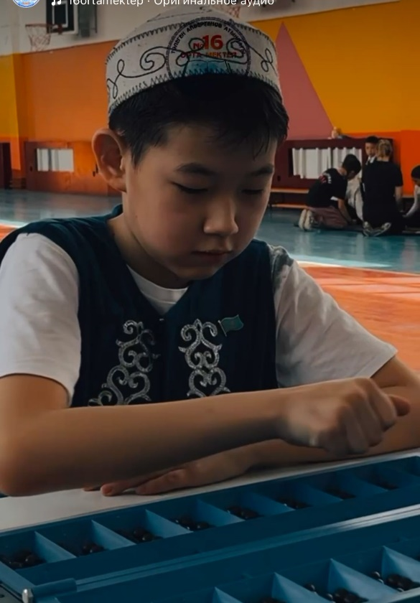 | https://www.instagram.com/reel/DHaaZHYooTm/?igsh=MWRtcGR2Nm0yc2JlZg==
143 | Наурыз көктем мейрамы | 20.03.2025 | 2580 | 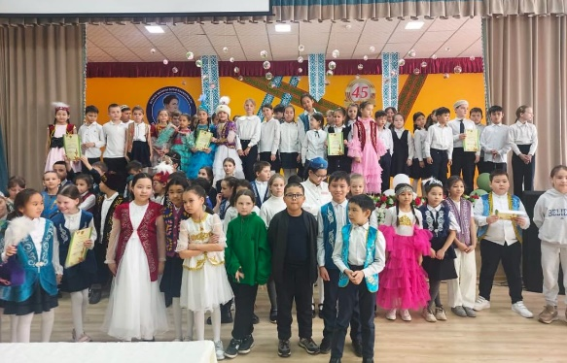 | https://www.instagram.com/p/DHbelnyoH8i/?igsh=ZW0zMzlhZGp3YWJ2  https://www.instagram.com/reel/DHc8s5koJT1/?igsh=MWdmcHFqNDNwcTBvcQ==  https://www.instagram.com/reel/DHk-SYwooFl/?igsh=MWdkeDdwZG41cTc3Mw==
144 | Астанада аутодеструктивті мінез-құлықтың алдын алу бойынша қалалық семинар өтті | 28.03.2025 | 40 | 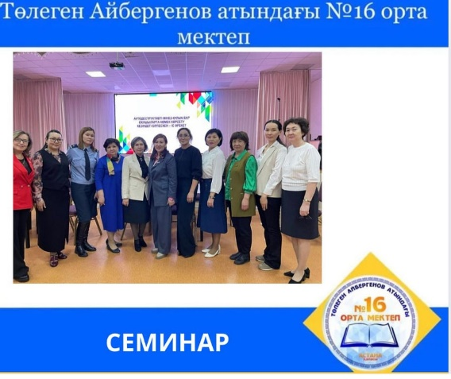 | https://www.instagram.com/p/DHvYn_bN_dS/?igsh=YWk5OWk4NDBudXR6
145 | Провел беседу учащимся 7 З классу оперуполномоченный отдела криминальной полиции УП района Байконыр ст.лейтенант полиции Ахметжанов А.Б. на тему: Административные правонарушения среди несовершеннолетних. | 02.04.2025 | 25 | 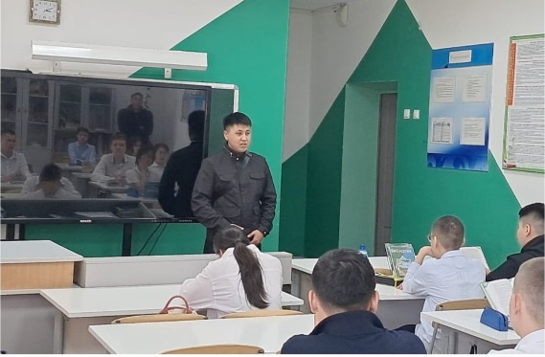 | https://www.instagram.com/p/DH8WzwStVui/?img_index=1&igsh=MTVkbHBtOWljd2FnNw==
146 | Провела лекцию старший о/у УПН ДП г. Астаны подполковник полиции Рахимова Л.Г. на тему: Профилактика наркотических средств и прекурсоров среди несовершеннолетних. Закладки.  Показан видеоматериал. | 03.04.2025 | 60 | 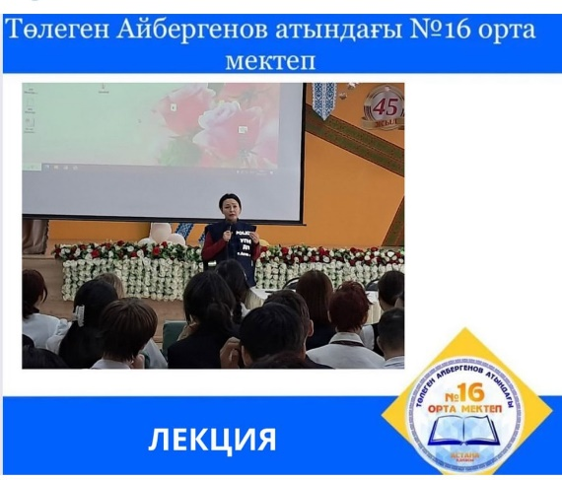 | https://www.instagram.com/p/DH-3OshtzMr/?igsh=M2NiaGN2cGwzdngw
147 | Уроки художественного труда: «Культура питания»! Между ученицами 6-7 классов | 03.04.2025 | 156 | 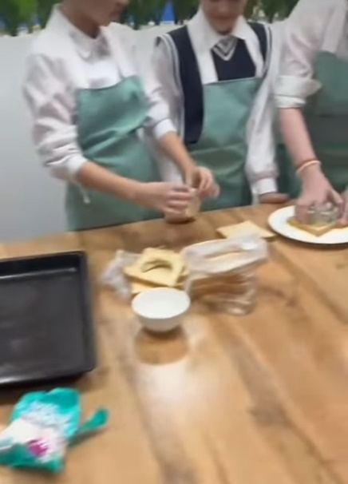 | https://www.instagram.com/reel/DH_RTyDIg3I/?igsh=cTNwMXA1NzVlc2p5  https://www.instagram.com/p/DIBspBlN1C5/?igsh=bGo2ZHFmZGVvZWFw
148 | 8 “Г” және 8 “Д” сынып оқушылары халықаралық орыс тілі пәні бойынша диктант жазу байқауына қатысып, өз білімдерін тексеріп көрді. Оқушылар “Тотальный диктант” жазу байқауына қатысқаны үшін сертификатпен марапатталды. | 05.04.2025 | 60 | 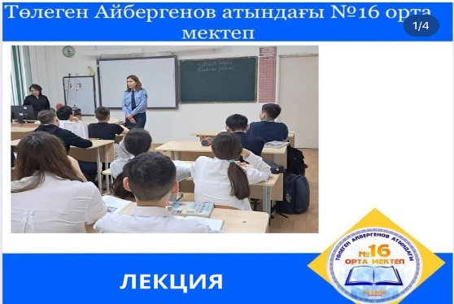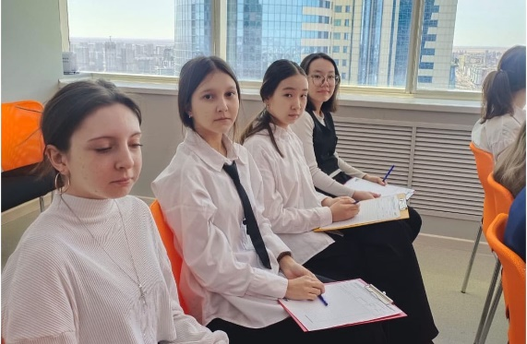 | https://www.instagram.com/p/DIECOwUte_4/?img_index=1&igsh=MWtxaG91ZnZmbHo1dQ==
149 | Мемлекет басшысы Қасым-Жомарт Тоқаевтың бастамасымен «Таза Қазақстан» экологиялық акциясы аясында №16 орта мектебінде сенбілік өткізілді. | 07.04.2025 | 350 | 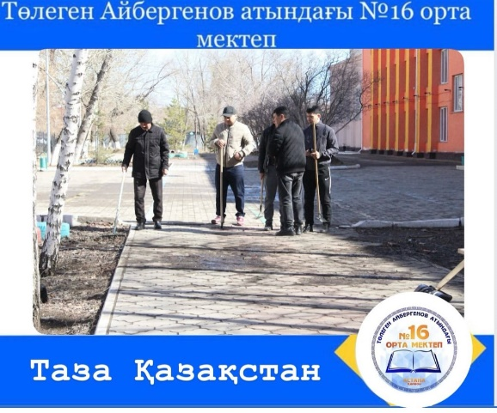 | https://www.instagram.com/p/DIIcRD2opsb/?igsh=Y3E2dDJpazJwZXE5
150 | Учащимся 11”Б” и 11”В” классов провели лекции инспектора ОЮП УП района Байконыр майор полиции Калиакпарова Г.Т. и лейтенант полиции Багабаева М.С. на тему: Правила поступления в учебные заведения МВД РК. | 07.04.2025 | 60 | 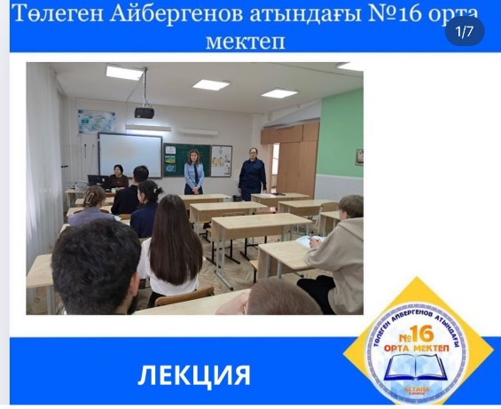 | https://www.instagram.com/p/DIJgrkWtnr8/?igsh=MXE2dDR1OXM5YnZ0Yw==
151 | 7 «Е» сынып оқушысы Пучков Ярославты үлкен жеңісімен шын жүректен құттықтаймыз! Ярослав хоккейден Қазақстан Республикасы чемпионатына қатысып, ел чемпионы атанды! | 09.04.2025 | 1 | 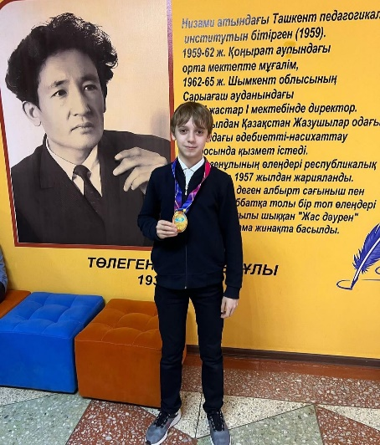 | https://www.instagram.com/p/DIOr6WStQVH/?igsh=MThmaGlkdXpjaGVmeA==
152 | Бастауыш сыныптардың онкүндігі жоспары бойынша 3-сыныптар арасында “Ғарышкерлер әлемі” тақырыбында шығарма жазу байқауы өткізілді. | 09.04.2025 | 24 | 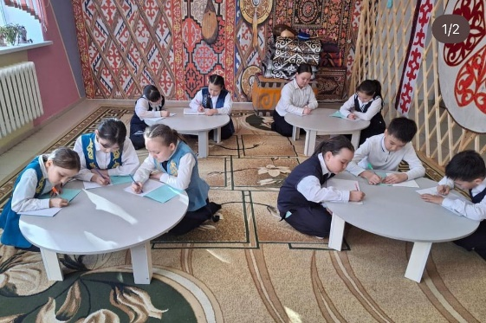 | https://www.instagram.com/p/DIOsF79tt1z/?igsh=bTJ3Yjk0cXZoaXRk
153 | Прошло родительское собрание, на котором обсудили все важные вопросы, касающиеся учебного процесса, успеваемости и предстоящих школьных мероприятий. | 11.04.2025 | 1800 | 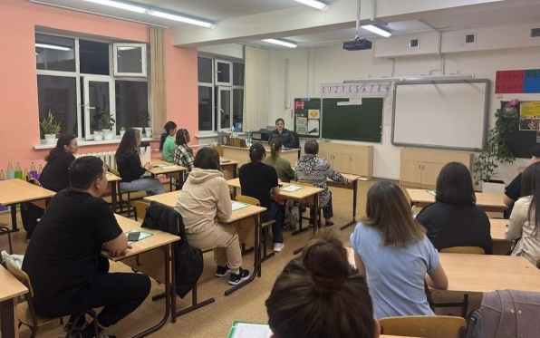 | https://www.instagram.com/p/DITPJ8boKfn/?igsh=MXZnNTRiM28zdmJoZw==
154 | "Чистый Казахстан" веселая суббота. | 12.04.2025 | 360 | 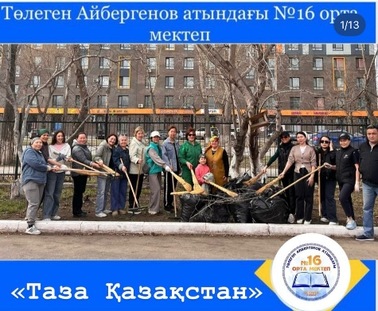 | https://www.instagram.com/p/DIV6x2dTsBL/?igsh=MWl6czB0NDd4NjY5dQ==  https://www.instagram.com/reel/DIV64CWTqQO/?igsh=dWJkcWx2OHllZWVr  https://www.instagram.com/p/DIV7JKyTN5e/?igsh=MWplcGZkODFjMnFpNw=  https://www.instagram.com/reel/DIWK_azIakB/?igsh=NjE3OGNuaWtvYnFm
155 | Аудандық дебат турниріне 9А сынып оқушылары Анель, Айдана, Амина қатысып 3 дәрежелі орынға ие болды Жетекшісі Жазира Ибраимова | 12.04.2025 | 3 | 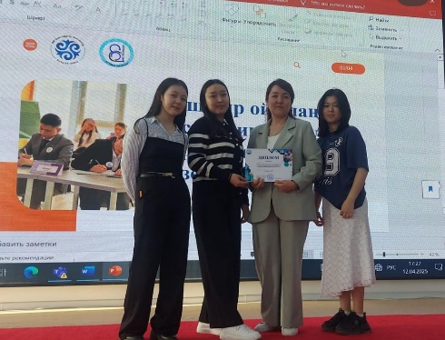 | https://www.instagram.com/p/DIWcSneT-Xu/?igsh=czBuYndicHg3OGNm
156 | « Тәжірибеден - шеберлікке, еңбектен - нәтижеге!» вожатыйлар апталығының ашылуы. | 14.04.2025 | 100 | 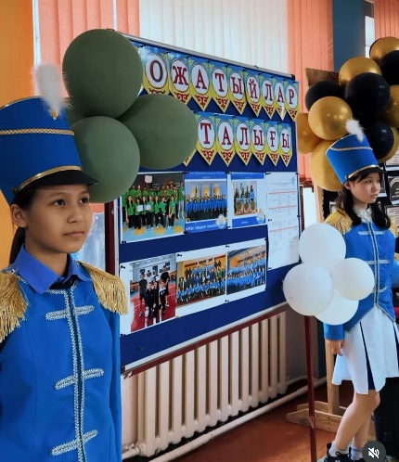 | https://www.instagram.com/reel/DIaxwECIYL5/?igsh=MWh6M2w0NzB5NHhldw==
157 | «Ғазиз Байтасов атындағы жас жол инспекторлары» Байқоңыр аудандық сілетінде жалпы білім беретін мектептер арасында өткен сайыста 3 орынды иеленді. | 15.04.2025 | 10 | 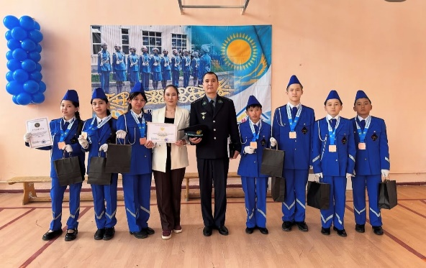 | https://www.instagram.com/p/DIddKUqIiVT/?igsh=amFsMHRkemtiM25p
158 | В рамках акции «Подросток» среди учащихся 8,9,10,11 классов провела лекцию начальник ОИС УП района Байконыр капитан полиции Валиева А.Б.на темы: Административные и уголовные правонарушения среди несовершеннолетних. Закладки. | 17.04.2025 | 1200 | 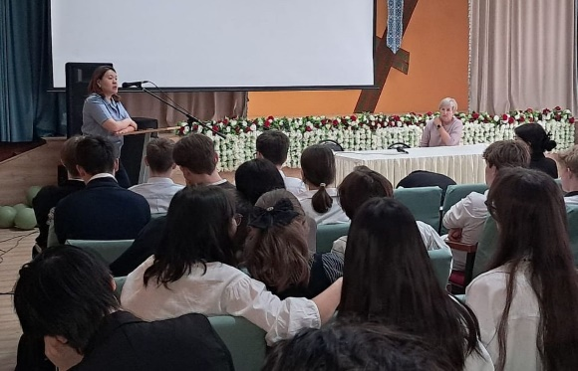 | https://www.instagram.com/p/DIij7PkN3WI/?igsh=MXAyOHBhamZzMXdhMQ==
159 | №16 орта мектебінің 8 “А,Ә” сынып оқушылары Ақмола облысында орналасқан “АЛЖИР” лагерінде танымдық экскурсияда болды. | 21.04.2025 | 28 | 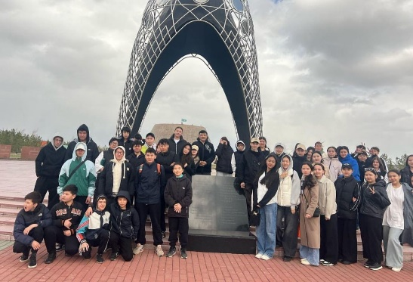 | https://www.instagram.com/p/DIswLOmN3UY/?igsh=MXFramM0MnY2ZHFmeQ==
160 | ALL FOR THE GAME қазақ лигасының фракциясы мекпетішілік 6-8 сынып арасында дебат турнирлерін өткізді. | 21.04.2025 | 362 | 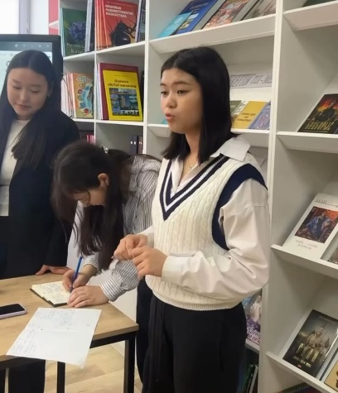 | https://www.instagram.com/reel/DItnlKzS-_x/?igsh=cjhkZ2k2ZDFwdzZi
161 | Ученики 7 “М” класса посетили современный спортивно-образовательный комплекс Sana Sport! | 22.04.2025 | 31 | 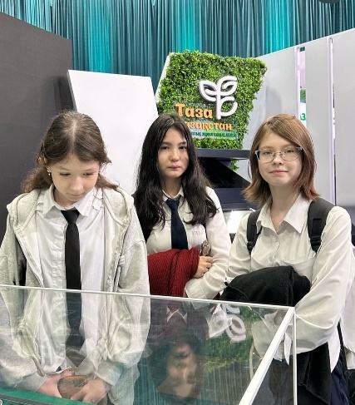 | https://www.instagram.com/p/DIwhfZ4tSTi/?img_index=1&igsh=MTNnemVmZ2U1dXJndA==
162 | Члены дебатного клуба нашей школы провели встречу на тему « Академическая честность - залог конкурентоспособного специалиста». | 22.04.2025 | 20 | 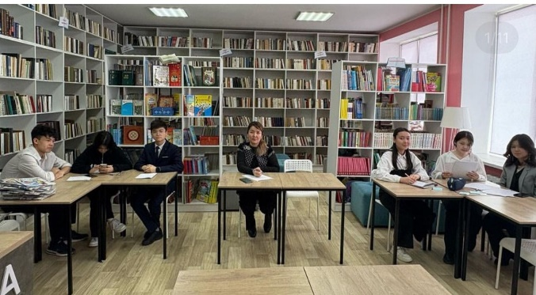 | https://www.instagram.com/p/DIxtMKOtm1g/?igsh=MWtiMzBnNzVtc2VzcA==
163 | Байқоңыр ауданында ұлттық кітап күніне орай мектеп оқушылары арасында білім сайысы өтті | 23.04.2025 | 30 | 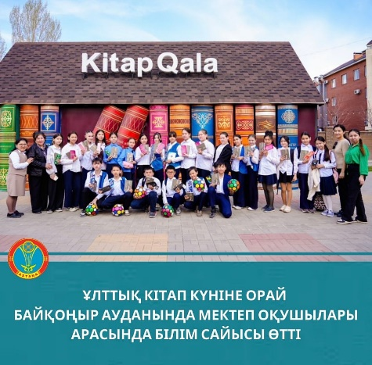 | https://www.instagram.com/p/DIyLjBzNgKV/?igsh=dGdycXNxa2cyM3hv
164 | Астана қаласы “Байқоңыр” ауданы аумағында 10.04.2025 - 06.05.2025 ж. аралығында “Жасөспірім” атты республикалық жедел алдын алу іс-шарасы өткізілуде. | 25.04.2025 | 1500 | 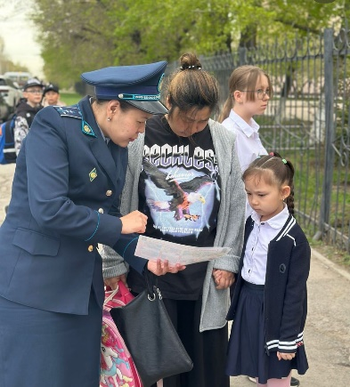 | https://www.instagram.com/p/DI20TEgiknn/?igsh=OHRlbncwcHVpM2F1
165 | Учащиеся 8 «Б», 8 «В», 8 «Г», 8 «Д», 8 «Е», 8 «З» и 8 «И» классов посетили музейно-мемориальный комплекс “Алжир” | 25.04.2025 | 180 | 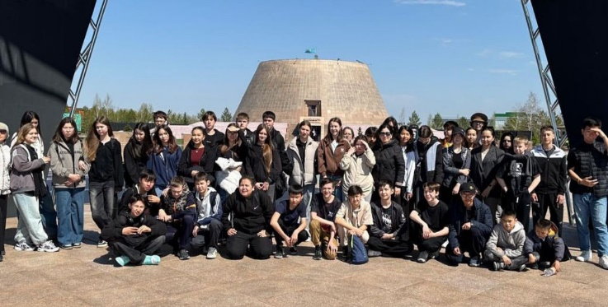 | https://www.instagram.com/p/DI22AYNMknO/?igsh=bTV1dzczdW4yZDFq
166 | Прошло родительское собрание на тему: « Безопасное детство - заботливые родители». | 25.04.2025 | 1500 | 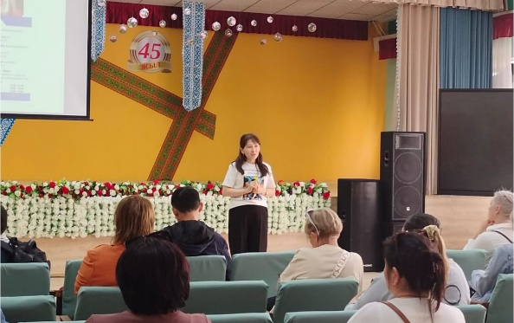 | https://www.instagram.com/p/DI3FVZ_JJX3/?img_index=1&igsh=MXAydWNxeTNpNDJyag==
167 | В рамках акции «Таза Қазақстан» учащиеся 9 классов в количестве 200 детей приняли участие в экофитнессе «Зарядись чистотой!» | 25.04.2025 | 180 | 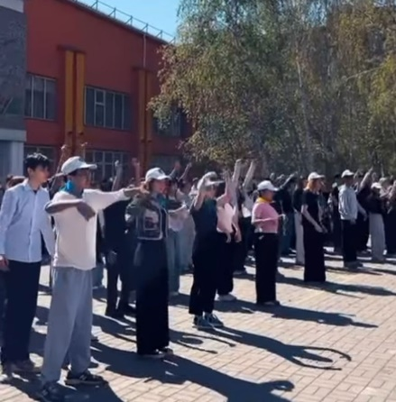 | https://www.instagram.com/reel/DI3c2gNp_rS/?igsh=MW5iZTNxcGE4bGt5NQ==
168 | В рамках концепции «Закон и порядок!», идеологии «Таза Қазақстан» проходил флешмоб под эгидой «Астана - есірткісіз қала!» | 25.04.2025 | 300 | 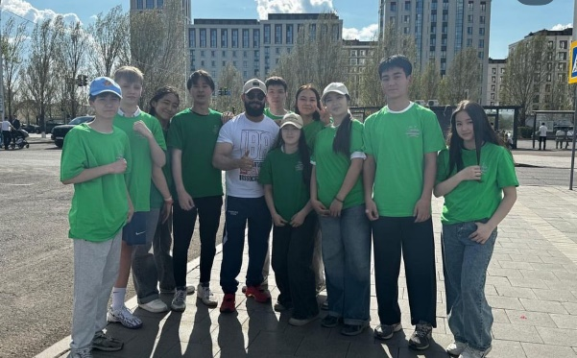 | https://www.instagram.com/p/DI32HMcpa-J/?igsh=bml3N20xM2dpNTJm
169 | Совет отцов средней школы 16 им.Т.Айбергенова ( 40 пап) с детьми приняли участие в городском мероприятии посадки деревьев | 26.04.2025 | 150 | 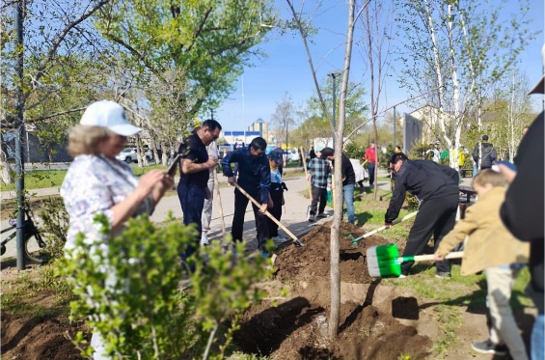 | https://www.instagram.com/p/DI5fkmyNixn/?img_index=1&igsh=MWp0a3E0N29zankzMQ==
170 | Астана қаласы “Байқоңыр” ауданы аумағында 10.04.2025 - 06.05.2025 ж. аралығында “Жасөспірім” атты республикалық жедел алдын алу іс-шарасы өткізілуде. | 28.04.2025 | 1500 | 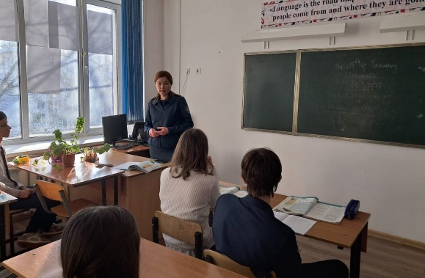 | https://www.instagram.com/p/DI_FvP_N_i5/?img_index=1&igsh=MXM0anF1aW1od3ExdA==
171 | 107-орта мектеп базасында «Инновациялық идеялар алаңы: STEAM және цифрлық білім беру» атты республикалық ғылыми семинар табысты ұйымдастырылды. | 29.04.2025 | 150 | 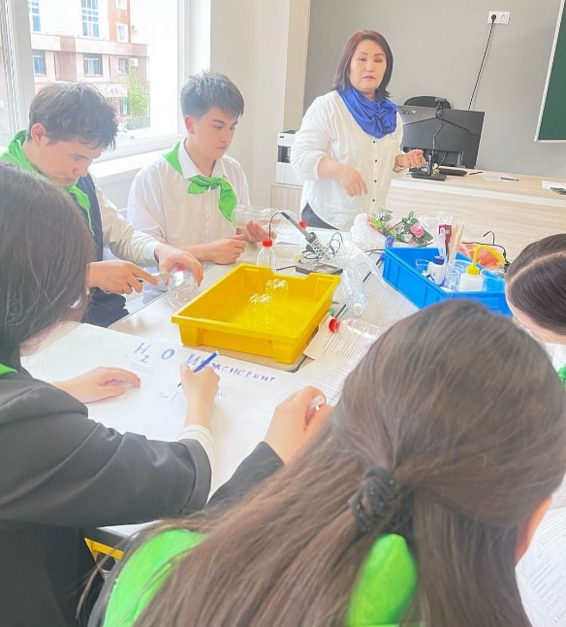 | https://www.instagram.com/p/DJBXa1Mtej_/?igsh=YmR1aXBzZmYxM3c5  https://www.instagram.com/p/DJBXyTrtSTm/?igsh=eGxjdDE5bG9pYXh3  https://www.instagram.com/p/DJBYJj5NaNT/?igsh=b3BxN2QxMWtvdDJx  https://www.instagram.com/p/DJCN-bpo-40/?igsh=MWx1NHE1OWZsMmhyaA==  https://www.instagram.com/p/DJCV5VEojAN/?igsh=MTlnbGU1ZXBkdG44Zw==
172 | 5-6 сынып оқушылары арасында Жас ұрпақтың отанға деген сүйіспеншілігін, рухын ояту үшін Патриоттық өлеңдер жарысы өткізілді | 05.05.2025 | 300 | 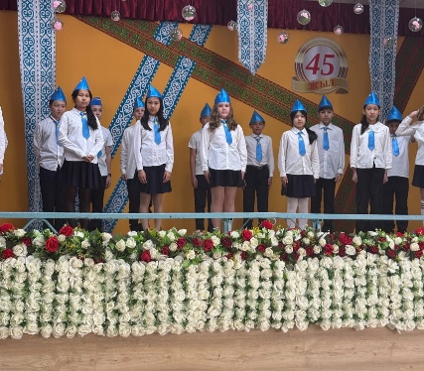 | https://www.instagram.com/p/DJW-8xQItVN/?igsh=MWlpcmx4ZXYyYWZvOQ==  https://www.instagram.com/reel/DJUzU68tPcz/?igsh=b3JlNGd0M2k2YnJi  https://www.instagram.com/reel/DJV3PtItWDU/?igsh=MW52bGR2dmtqeXpxdA==
173 | Жеңіс күні мерекесіне орай ІІМ өткен іс-шараға мектебіміздің Жас сақшы сыныбы қатысты . «Жас сақшы » сыныбында үздік оқығаны және мектептегі жоғары жетістіктері үшін оқушыларды полиция генерал-майоры М.С.Төлебаев оқушыларды Алхыс хатпен марапаттады. | 07.05.2025 | 30 | 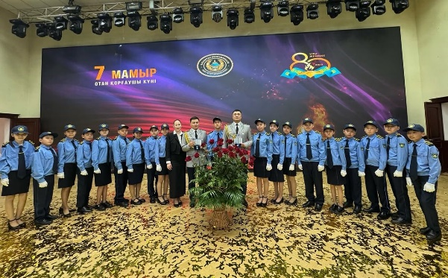 | https://www.instagram.com/p/DJXAAN2Ibp6/?igsh=YTZydW9meTV3dnVu
174 | Ученики №16 средней школы имени Т. Айбергенова поздравили всех мам видеопоздравлением ко дню матери | 11.05.2025 | 2300 | 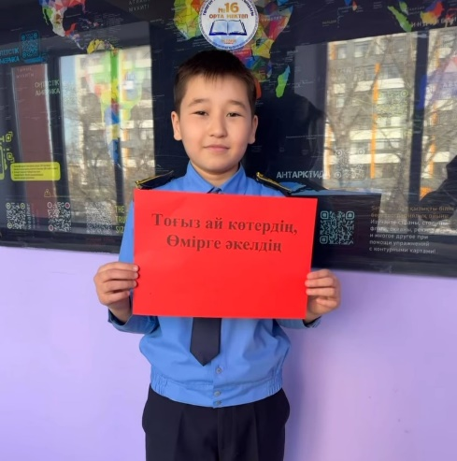 | https://www.instagram.com/reel/DJgZgjhou8x/?igsh=MTNxaHFmOXBkbjNyeQ==  https://www.instagram.com/reel/DJgkb9bINHP/?igsh=b2x5amh3OGwxZ3Jq  https://www.instagram.com/reel/DJhTY94oBlf/?igsh=OWV6Y3U5OW84d3Ix  https://www.instagram.com/reel/DJhZ65WNlvU/?igsh=YTVvaGV6N2MxdjFi
175 | Т.Айбергенов атындағы №16 орта мектебінде ауған соғысы ардагерлермен ерлік сабағы өтті. | 14.05.2025 | 200 | 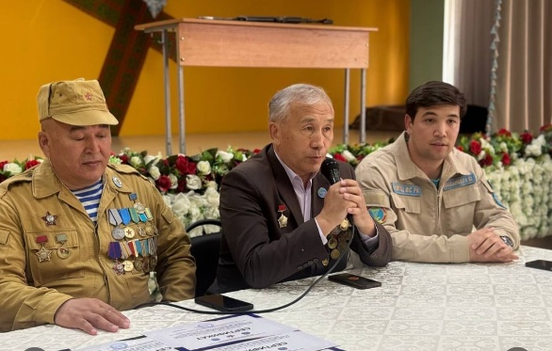 | https://www.instagram.com/p/DJomKwzs3ix/?igsh=MzEyNGc2bW1peTR1
176 | 15 мамыр халықаралық отбасы күні! | 15.05.2025 | 2300 | 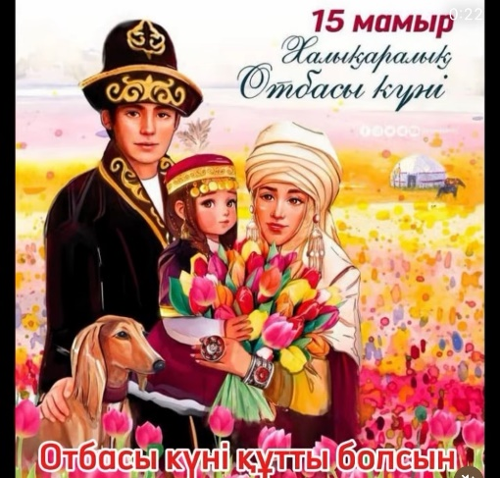 | https://www.instagram.com/reel/DJqgtfAIUvw/?igsh=ZmswbzZrcXVsY3Jp  https://www.instagram.com/reel/DJqg2NuI-7t/?igsh=MXA0anQyazQ0cHZiZw==  https://www.instagram.com/p/DJqhJ0eIuuN/?igsh=b3lxdzhlc3poNXk4  https://www.instagram.com/p/DJqhTCBIJwx/?igsh=cHI5NHYzM2hnM3Ix  https://www.instagram.com/p/DJqhcfgI_0f/?igsh=NGI4ajhnYm1tYWpz  https://www.instagram.com/p/DJqhrC5IERl/?igsh=MXd5MnE3MmozeHYzNw==
177 | Среди учащихся 8-х классов были проведены лекции старшим о/у УПН ДП г. Астаны подполковником полиции Рахимовой Л.Г., начальником ОИС УП района Байконыр капитаном полиции Валиевой А.Б., инспектором ОЮП майором полиции Калиакпаровой Г.Т., о/у ОКП капитаном полиции Рәпілбек Н. на темы: “Профилактика административных и уголовных правонарушений среди несовершеннолетних. “ Лекция о запрете употребления и распространения наркотических средств.” | 15.05.2025 | 300 | 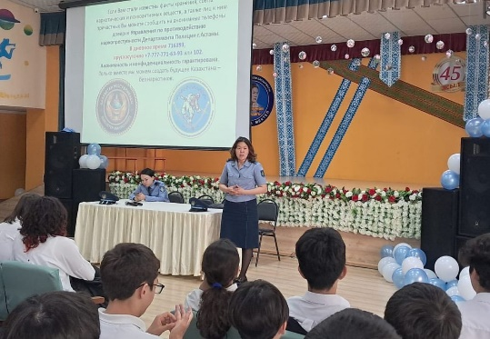 | https://www.instagram.com/p/DJqiPEINf1a/?igsh=MXJsdXR2ZjNtdXNndg==
178 | Республикалық «Таза Қазақстан» экологиялық акциясы аясында «Жасыл желек жердің көркі» тақырыбында мектеп ауласын абаттандыру жүргізілді | 17.05.2025 | 60 | 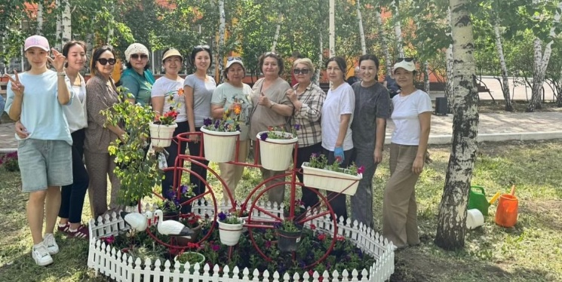 | https://www.instagram.com/p/DJ0jU3_CIli/?igsh=N3BwZTMxYmtrejQy
179 | Республиканский видеоконкурс «Шекара мұрагері», организованного Пограничной службой КНБ | 20.05.2025 | 90 | 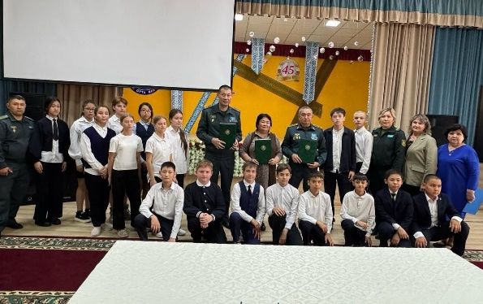 | https://www.instagram.com/p/DJ36tJhIcrl/?igsh=aWQ5MDA0N3RiNGQz
180 | Т.Айбергенов атындағы № 16 орта мектебінде Білімім - Отаныма тақырыбында барлық сыныпта тәрбие сағаттары өткізілді. | 23.05.2025 | 250 | 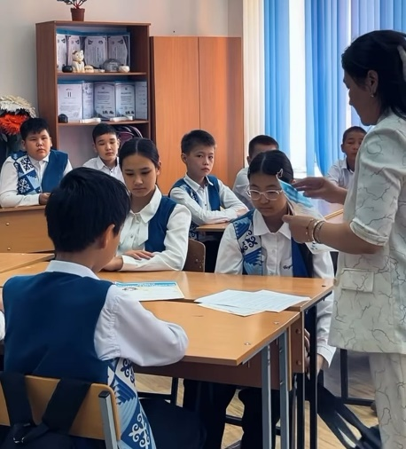 | https://www.instagram.com/reel/DJ_jQl2o70W/?igsh=MThqem5kdHg0eXp3ZQ==  https://www.instagram.com/p/DJ_j4x4Ioij/?igsh=bzU0Nzk5YmV6bWV3  https://www.instagram.com/reel/DJ_xoV4ISvC/?igsh=dmtiOTAwc2w4ZWlm
181 | «Жас сақшы» сыныбы Байқоңыр ауданының ПД -ның ұйымдастыруымен өткен халықаралық балаларды қолдау күні аясында өткізілген іс-шараға қатысты | 23.05.2025 | 28 | 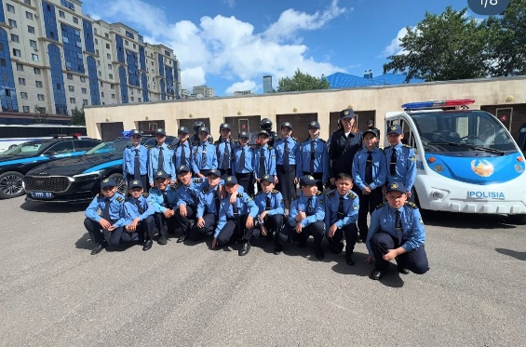 | https://www.instagram.com/p/DJ_7cSETbQt/?igsh=ejB2MzY5ZDlmejZy  https://www.instagram.com/p/DJ_9XWAogJr/?igsh=anM2djBqOHplOWxm
182 | В средней школе 16 им.Т.Айбергенова прошла торжественная линейка “ Мектебім саған мың алғыс”, посвященный выпускникам‼️ Линейка прошла в торжественной обстановке‼️54 выпускника получили поздравления и напутственные слова‼️. | 24.05.2025 | 3000 | 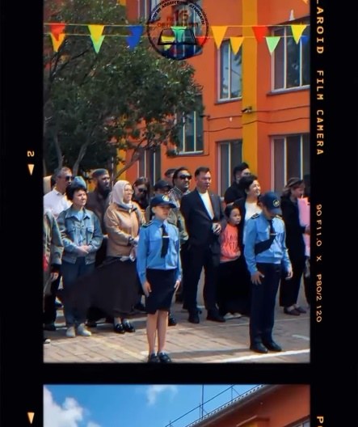 | https://www.instagram.com/reel/DKCEAiHoNF1/?igsh=aDNsbmtpemFxMWNm

Директор С.Азимханова

Исп. Г.Нурмаганбетова

